
جامعة آل البيت
Al Al-Bayt University

Prince Al Hussein bin Abdullah College of Information Technology
Department of Data Science and Artificial Intelligence
"AI Football Match Prediction & Analysis"

Prepared by:
Name | ID
Saleh Nour Al-Din Saleh Abdullah | 2200908644
Qutaiba Khairi Hassan Hassan | 2200908558
Mahmoud Armiya Mahmoud Al-Rousan | 2200908691
Abdulrahman Mohammad Saleh Al-Rifai | 2200908622

Supervised by:
Dr. Mahmoud Jawarneh

Committee Members | Signatures
………………………………… | …………………………………
………………………………… | …………………………………

May - 2026

ACKNOWLEDGMENT
In the name of Allah, the Most Gracious, the Most Merciful. All praise and gratitude are due to Allah Almighty, who granted us the strength, patience, and knowledge to complete this graduation project.
We would like to extend our deepest gratitude and sincere appreciation to our esteemed supervisor, Dr. Mahmoud Jawarneh, for his continuous support, valuable guidance, and constructive feedback throughout the development of this project. His expertise in Data Science and Artificial Intelligence, combined with his patience and dedication, has been a cornerstone of our academic journey. His insightful suggestions and willingness to share his knowledge transformed challenges into learning opportunities and pushed us to achieve a higher standard of work.
We are also profoundly grateful to the Department of Data Science and Artificial Intelligence at the Prince Al Hussein bin Abdullah College of Information Technology, and to all the faculty members who taught us during our years of study at Al al-Bayt University. The strong academic foundation they provided in machine learning, data engineering, deep learning, and software development was essential for the successful completion of this work.
Our heartfelt thanks go to our families for their unwavering love, encouragement, and patience during the long hours of research, programming, and writing. Their belief in us has been our greatest source of motivation.
Finally, we would like to thank our colleagues and friends who supported us with valuable discussions, technical advice, and moral support throughout this journey. This project would not have been possible without the contribution of every individual mentioned above.

ABSTRACT
Football, as the most popular sport in the world, generates an enormous volume of statistical data through international competitions. The FIFA World Cup, held every four years, represents the pinnacle of international football and attracts global attention from fans, analysts, and researchers. With the upcoming 2026 FIFA World Cup, hosted jointly by the United States, Mexico, and Canada, the demand for accurate and explainable match outcome predictions has reached an unprecedented level. Traditional predictions are often based on subjective opinions, expert intuition, or simple statistics, which lack scientific rigor and reproducibility.
This graduation project presents the design and development of an integrated Artificial Intelligence platform for predicting football match outcomes, focusing specifically on the FIFA World Cup 2026. The system combines a robust Machine Learning pipeline with an interactive web-based interface to deliver probabilistic predictions for any match between qualified teams. The proposed solution addresses three persistent problems in football outcome forecasting: the reliance on non-scientific predictions, the absence of unified platforms that combine historical analysis with prediction, and the lack of transparency in explaining the factors that influence predicted results.
The system was developed following the Cross-Industry Standard Process for Data Mining (CRISP-DM) methodology. A comprehensive dataset of 49,071 international football matches was processed and refined into a final clean dataset of 8,221 matches spanning from January 2010 to January 2026. Eighteen engineered features were extracted from this data, including FIFA ranking differentials, team form indicators, head-to-head historical performance, average goals scored and conceded, and tournament importance weights. Initially, a single Random Forest classifier was trained on competitive matches and achieved an accuracy of 61.62% on three-class outcome prediction. To improve performance, the system was redesigned around a dual-model architecture in which a Voting Ensemble (Random Forest + XGBoost + Logistic Regression) handles the win/loss decision (79.8% accuracy) and a complementary model detects draws separately (73.4% accuracy).
The system is delivered through a Flask-based RESTful API that serves predictions in real time, integrated with a responsive web interface built using HTML, CSS, and JavaScript. The interface visualizes the complete tournament structure including the group stage and knockout bracket, and allows users to interactively predict any match and view detailed probability breakdowns through dynamic charts. By combining rigorous data preparation, careful feature engineering, transparent model evaluation, and modern web technologies, the proposed platform offers a scientific, reproducible, and user-friendly tool that supports football analysts, fans, and decision makers in understanding and anticipating match outcomes.

Table of Contents
CHAPTER 1: Project Overview 7
1.1 Introduction 7
1.2 Problem Statement 8
1.3 Proposed Solution 9
1.4 Project Objectives 10
1.5 Project Scope 11
1.5.1 In Scope 11
1.5.2 Out of Scope 12
1.6 Target Users and Beneficiaries 13
Football Fans and General Audience 13
Sports Analysts and Football Journalists 13
Students and Researchers in Data Science 13
Coaching Staff and Football Federations 13
Educators and Academic Supervisors 14
CHAPTER 2: System Analysis 15
2.1 Introduction 15
2.2 Data Collection and Sources 15
2.2.1 International Match Results Dataset 16
2.2.2 FIFA Ranking History Dataset 16
2.2.3 Penalty Shootouts Dataset 16
2.2.4 Former Country Names Dataset 16
2.2.5 EA Sports FC 26 Player Attributes Dataset 16
2.2.6 World Cup Top Scorers and Goalscorers Datasets 17
2.3 System Development Methodology 17
2.3.1 CRISP-DM for the Data and Modeling Pipeline 17
2.3.2 Agile Principles for Web Application Development 18
2.3.3 Justification of the Hybrid Methodology 18
2.3.4 Development Timeline 18
2.4 Algorithm Selection and Justification 19
2.4.1 Characteristics of the Football Prediction Problem 20
2.4.2 Candidate Algorithms Summary 20
2.4.3 Random Forest Selection Justification 21
2.4.4 Comparative Summary Table 21
2.5 Understanding Accuracy in Football Prediction 22
2.5.1 The Theoretical Ceiling of Football Prediction 22
2.5.2 Comparison with Random and Majority-Class Baselines 22
2.5.3 Comparison with Published Football Prediction Studies 23
2.5.4 Why International Football Is Harder Than Club Football 24
2.5.5 Why Accuracy Alone Is Not the Only Metric 24
2.6 Related Work and Literature Review 25
2.6.1 Liu (2024) — FIFA World Cup Prediction with Random Forests 25
2.6.2 Prasetio and Harlili (2016) — Tree-Based Models on EPL Data 25
2.6.3 Hubáček, Šourek, and Železný (2019) — Probabilistic Soccer Prediction 26
2.6.4 Groll, Ley, Schauberger, and Van Eetvelde (2019) — Hybrid Random Forest with Poisson Ratings 26
2.6.5 Atta Mills, Mwangi, and Mensah (2024) — Random Forest vs Gradient Boosting 26
2.6.6 Comparative Summary and Research Gap 27
2.7 Tools and Technologies 27
2.7.1 Programming Languages and Core Libraries 27
2.7.2 Machine Learning Libraries 27
2.7.3 Backend Technologies 28
2.7.4 Frontend Technologies 28
2.7.5 Development Environment 28
2.8 Functional Requirements 28
2.9 Non-Functional Requirements 29
Performance 29
Usability 30
Reliability 30
Maintainability 30
Portability 30
CHAPTER 3: System Design 31
3.1 Introduction 31
3.2 System Architecture Design 31
3.2.1 Architecture Overview 31
3.2.2 Presentation Layer 32
3.2.3 Application Layer 33
3.2.4 Data Layer 33
3.3 Data Pipeline Architecture 34
3.3.1 Pipeline Stages 34
3.3.2 Pipeline Outputs 35
3.4 System Modeling 35
3.4.1 Use Case Diagram 36
3.4.2 Sequence Diagram of the Prediction Workflow 37
3.4.3 Data Flow Diagram 39
3.5 API Design 40
3.5.1 Health-Check Endpoint 40
3.5.2 Prediction Endpoint 40
3.5.3 Error Handling 41
3.6 User Interface Design 41
3.6.1 Visual Identity 42
3.6.2 Group Stage View 42
3.6.3 Knockout Bracket View 43
3.6.4 Match Prediction Modal and Result Page 44
3.6.5 Responsive Design Considerations 45
CHAPTER 4: System Implementation 46
4.1 Introduction 46
4.2 Development Environment 46
4.3 Data Cleaning Implementation 47
4.3.1 Loading the Raw Datasets 47
4.3.2 Filtering by Date 47
4.3.3 Handling Missing Values 48
4.3.4 Filtering to World Cup-Relevant Teams 48
4.3.5 Computing the Match Result Label 48
4.3.6 Computing the Tournament Weight 49
4.3.7 Joining the FIFA Ranking History 49
4.3.8 Integrating Penalty Shootouts 50
4.3.9 Final Cleaning Output 50
4.4 Feature Engineering Implementation 50
4.4.1 Rank Differential 50
4.4.2 Team Form Indicators 51
4.4.3 Head-to-Head Ratio 51
4.4.4 Average Goals Scored and Conceded 51
4.4.5 Tournament Weight and Neutral Flag 52
4.4.6 Final Feature Matrix 52
4.5 Model Training Implementation 52
4.5.1 Model Configuration 52
4.5.2 Train and Test Split 53
4.5.3 Experiment 1 — All Matches 53
4.5.4 Experiment 2 — Without Friendly Matches 53
4.5.5 Experiment 3 — Competitive Matches Only 54
4.5.6 Per-Class Performance of the Final Model 54
4.5.7 Upgrade to a Dual-Model Architecture 55
4.5.8 Model Serialization 55
4.6 Backend Implementation 56
4.6.1 The Prediction Module 56
4.6.2 The Flask Web Service 56
4.6.3 Running the Backend 57
4.7 Frontend Implementation 57
4.7.1 The Group Stage Page 57
4.7.2 The Knockout Bracket Page 58
4.7.3 The Prediction Modal 59
4.7.4 The Result Page 59
4.7.5 Visual Identity and Styling 60
4.8 System Integration and Testing 60
CHAPTER 5: Testing and Evaluation 62
5.1 Introduction 62
5.2 Data Pipeline Testing 62
5.3 Machine Learning Model Evaluation 63
5.3.1 Overall Accuracy 63
5.3.2 Per-Class Performance 63
5.3.3 Confusion Matrix Analysis 64
5.3.4 ROC Curve Analysis 64
5.3.5 Comparison with Baselines 64
5.4 Backend API Testing 66
5.5 Frontend Testing 66
5.6 End-to-End Integration Testing 67
5.7 Real Prediction Examples 68
5.8 Evaluation Summary 68
CHAPTER 6: Conclusion and Future Work 70
6.1 Introduction 70
6.2 Project Summary 70
6.3 Achievements 70
6.4 Project Contributions 71
6.4.1 Scientific Contribution 71
6.4.2 Engineering Contribution 71
6.4.3 Educational Contribution 72
6.5 Limitations 72
6.5.1 Predictive Accuracy 72
6.5.2 Feature Set Scope 72
6.5.3 Draw Prediction 72
6.5.4 Pre-Match Predictions Only 72
6.5.5 Limited Player-Level Analysis 73
6.6 Future Work 73
6.6.1 Incorporating Player-Level Features 73
6.6.2 Algorithm Comparison and Hyperparameter Optimization 73
6.6.3 Score Prediction 73
6.6.4 Live In-Game Prediction 74
6.6.5 Mobile Applications 74
6.6.6 Multi-Language Support 74
6.6.7 Tournament-Wide Simulation 74
6.7 Conclusion 74
References 76

CHAPTER 1: Project Overview

1.1 Introduction
Football is widely regarded as the most popular sport in the world, with billions of followers across every continent and a deeply rooted presence in cultures, economies, and the daily lives of nations. International football competitions, and particularly the FIFA World Cup, represent moments of global excitement that unite hundreds of millions of viewers around a single sporting event. The 2026 FIFA World Cup, scheduled to be hosted jointly by the United States, Canada, and Mexico from June 11 to July 19, 2026, is expected to be the largest in the history of the tournament, expanding for the first time to forty-eight participating national teams distributed across twelve groups and culminating in a one hundred and four-match competition spread over sixteen world-class stadiums.
Alongside the growing scale of these tournaments, the volume of football-related data generated globally has expanded dramatically. Match results, goal scorers, player statistics, FIFA rankings, and team-level performance indicators are now systematically recorded and made publicly available through reliable open-data platforms. This explosion of structured football data has created an unprecedented opportunity for the application of modern data analysis and Artificial Intelligence techniques to extract patterns, identify trends, and produce data-driven insights that go far beyond traditional sports commentary.
Artificial Intelligence and Machine Learning have already proven to be transformative tools across many fields, including healthcare, finance, transportation, and cybersecurity. In the context of sports analytics, Machine Learning offers a scientifically grounded alternative to subjective opinion-based predictions by allowing models to learn from thousands of historical matches and identify the underlying factors that systematically influence the outcomes. Instead of relying on a single expert opinion or a simple head-to-head comparison, an AI-driven prediction system can simultaneously consider dozens of variables — such as historical form, attacking strength, defensive solidity, the relative ranking of the teams, and the importance of the tournament — to produce a probabilistic estimate that is reproducible, explainable, and grounded in real-world evidence.
Despite the wide availability of football data, there remains a gap in accessible platforms that combine clear match prediction, historical analysis, and understandable explanations for general football users.
This graduation project addresses this gap by designing and implementing a complete Artificial Intelligence platform dedicated to predicting and analyzing the matches of the FIFA World Cup 2026. The system combines a rigorous Machine Learning pipeline with a modern, interactive web interface to deliver probabilistic match predictions in a way that is accessible to non-specialists while remaining transparent for technically minded users. By unifying historical performance analysis, attacking and defensive indicators, head-to-head statistics, FIFA ranking history, and tournament context within one cohesive system, the proposed platform aims to support football fans, analysts, and decision makers in understanding the dynamics of international matches and anticipating their possible outcomes with a higher level of confidence.

1.2 Problem Statement
Although football generates a massive amount of structured data and attracts an enormous global audience, the way in which match outcomes are predicted and discussed today still suffers from several significant limitations. These limitations affect both casual fans and professional analysts, and they motivated the design of the proposed system.
First, the majority of public football predictions remain heavily based on personal opinions, intuition, and unstructured expert commentary. Television panels, sports columns, and social media discussions often produce predictions that are emotional, biased toward popular teams, or driven by recent media narratives rather than by a systematic analysis of historical data. Two analysts examining the same match can reach completely different conclusions without providing any reproducible justification. This subjectivity weakens the credibility of such predictions and makes it impossible to evaluate them objectively over time.
Second, even when statistical data is used, it is typically applied in a fragmented and superficial manner. A common approach is to look only at the recent results of the two teams involved, or to consider a single indicator such as the FIFA ranking. Such approaches ignore the multidimensional nature of football, where outcomes are influenced by a complex interaction of attacking strength, defensive performance, recent form, head-to-head history, the importance of the tournament, and the home or neutral nature of the match. The lack of an integrated analytical framework leads to predictions that fail to capture the full picture and that perform poorly when tested across a large number of matches.
Third, there is currently no widely available, easy-to-use platform that brings together the historical analysis of teams and the prediction of upcoming matches within a single integrated system. Football fans and analysts must consult multiple websites and databases to gather match histories, player statistics, FIFA rankings, and tournament schedules, and then attempt to combine this information manually. The absence of a unified solution makes the prediction process time-consuming, inconsistent, and largely inaccessible to non-technical users.
Fourth, even the few existing data-driven prediction tools tend to function as opaque black boxes. They display a predicted winner or a single probability number without explaining which factors influenced the result. In a domain where users naturally want to understand the reasoning behind a prediction — such as why a top-ranked team is expected to lose, or why a draw is more likely than an outright winner — this lack of transparency damages user trust and reduces the educational value of the system.
Fifth, with the upcoming FIFA World Cup 2026 introducing a new format with forty-eight teams, twelve groups of four, and a record number of one hundred and four matches across sixteen stadiums in three host countries, the need for a structured, scalable, and tournament-aware prediction system becomes more pressing than ever. Generic football prediction tools are not specifically designed to handle the unique characteristics of this expanded format, including the new third-place qualification rules and the resulting Round of 32, and therefore cannot offer a complete tournament-level forecasting experience.
In summary, the central problem addressed by this project is the absence of a scientific, integrated, transparent, and tournament-specific Artificial Intelligence platform capable of predicting and analyzing the matches of the FIFA World Cup 2026 based on rich historical data. Our work aims to fill this gap by combining a Machine Learning pipeline trained on more than 8,000 international matches with an interactive web interface designed to make predictions accessible, explainable, and engaging for a wide audience.

1.3 Proposed Solution
To address the problems described in the previous section, this project proposes the design and implementation of an integrated Artificial Intelligence platform dedicated to predicting and analyzing the matches of the FIFA World Cup 2026. The proposed solution is structured as a complete end-to-end pipeline that begins with the collection of raw historical data and ends with an interactive web application capable of producing real-time predictions for any match between qualified national teams.
The first component of the proposed solution is a comprehensive data engineering pipeline. Multiple high-quality open datasets are integrated, including the international match results dataset, the FIFA ranking history dataset, the penalty shootouts dataset, the former country names mapping dataset, and the EA Sports FC 26 player attribute dataset. These sources are systematically cleaned, harmonized, and merged to produce a unified, internally consistent dataset of more than eight thousand competitive international matches covering the period from January 2010 to January 2026. Particular attention is given to resolving inconsistencies in team naming conventions across different sources and to associating each match with the FIFA ranking that was actually in effect at the time the match was played, in order to avoid temporal data leakage.
The second component is a feature engineering module that transforms raw match records into a structured, model-ready representation. Eighteen carefully designed features are derived for every match, including the difference between the FIFA ranks of the two teams, the recent form of each team measured over their last five matches, the head-to-head historical performance over the last ten encounters, the average number of goals scored and conceded by each team in their most recent matches, the importance weight of the tournament in which the match takes place, and a flag indicating whether the match is played on neutral ground. Together, these features provide the model with a rich, multidimensional view of each fixture that captures attacking quality, defensive solidity, momentum, historical rivalry, and contextual importance.
The third component is a Machine Learning pipeline. An initial Voting Ensemble model was trained as a baseline (61.62% accuracy). To overcome the difficulty of draw prediction inherent to football, the final design adopts a dual-model architecture: a Voting Ensemble combining Random Forest, XGBoost, and Logistic Regression for win/loss classification (79.8%), and a dedicated draw-detection model (73.4%). The Random Forest was selected after comparing its behaviour with other candidate algorithms because of its strong performance on tabular data, its natural ability to handle non-linear relationships among features, its built-in resistance to overfitting through bagging and feature subsampling, and the interpretability provided by feature importance analysis. The model is trained to classify each match into one of three possible outcomes — home win, draw, or away win — and to produce a probability estimate for each of these classes. The final model used in the platform is trained specifically on the most competitive subset of matches, namely qualification matches and major continental and intercontinental tournament matches, in order to align the training distribution with the type of fixtures that will appear in the World Cup.
The fourth component is a backend service implemented in Python using the Flask web framework. This service exposes a RESTful API that loads the trained model and the feature definitions at startup, accepts requests containing the names of two teams, dynamically retrieves their most recent statistics from the historical dataset, computes the corresponding feature vector, invokes the Machine Learning model, and returns a structured JSON response containing the predicted outcome, the probability of each class, and the confidence level. The backend is designed to be lightweight, fast, and easy to integrate with any client application.
The fifth component is a complete interactive web interface implemented using HTML, CSS, and JavaScript, supported by the Chart.js library for dynamic data visualization. The interface presents the entire structure of the FIFA World Cup 2026, including the twelve groups of the group stage, the daily list of fixtures, and the full knockout bracket from the Round of 32 through to the final. Users can navigate through the tournament calendar day by day, select any specific match, and view a detailed prediction screen that displays the win, draw, and loss probabilities, the predicted winner, the model's confidence level, and an interactive bar chart visualizing the probabilities. The interface is designed in Arabic and adopts a modern visual style inspired by the official identity of the tournament, in order to provide an experience that is both informative and visually engaging.
Together, these components form a unified platform that transforms raw historical football data into transparent, probability-based predictions through a deployable machine learning model and an interactive web interface.

1.4 Project Objectives
The overarching objective of this project is to design, develop, and validate a complete Artificial Intelligence platform that produces reliable, transparent, and tournament-aware predictions for the matches of the FIFA World Cup 2026. To make this overarching objective concrete and measurable, it is decomposed into the following specific objectives:
- To collect, clean, and integrate multiple open football datasets — including the international match results dataset, the FIFA ranking history dataset, the penalty shootouts dataset, and the player attribute dataset — into a single, internally consistent dataset suitable for Machine Learning.
- To design and implement a feature engineering pipeline that transforms raw match data into a structured representation, capturing FIFA ranking differentials, recent form indicators, head-to-head historical performance, attacking and defensive averages, tournament importance, and home or neutral context.
- To train and evaluate a multi-class Machine Learning classifier capable of producing probabilistic predictions for the three possible outcomes of a football match: home win, draw, and away win, with particular emphasis on Random Forest as the primary algorithm.
- To analyze the relative importance of the engineered features in the trained model and to use this analysis as a basis for explaining and validating the predictions produced by the system.
- To develop a Python-based backend service using the Flask web framework that exposes the trained model through a clean RESTful API, returning structured probability-based prediction responses to any compatible client.
- To design and implement a fully interactive Arabic-language web interface that presents the complete structure of the FIFA World Cup 2026, including the twelve groups, the daily fixture calendar, and the knockout bracket from the Round of 32 to the final.
- To integrate the web interface with the prediction API in a seamless manner, allowing users to select any match between qualified teams and to view its predicted outcome, class probabilities, confidence level, and an interactive probability chart.
- To validate the proposed system through quantitative model evaluation metrics — including overall accuracy, per-class precision, recall, and F1-score — and through qualitative testing of the user interface against realistic match scenarios.
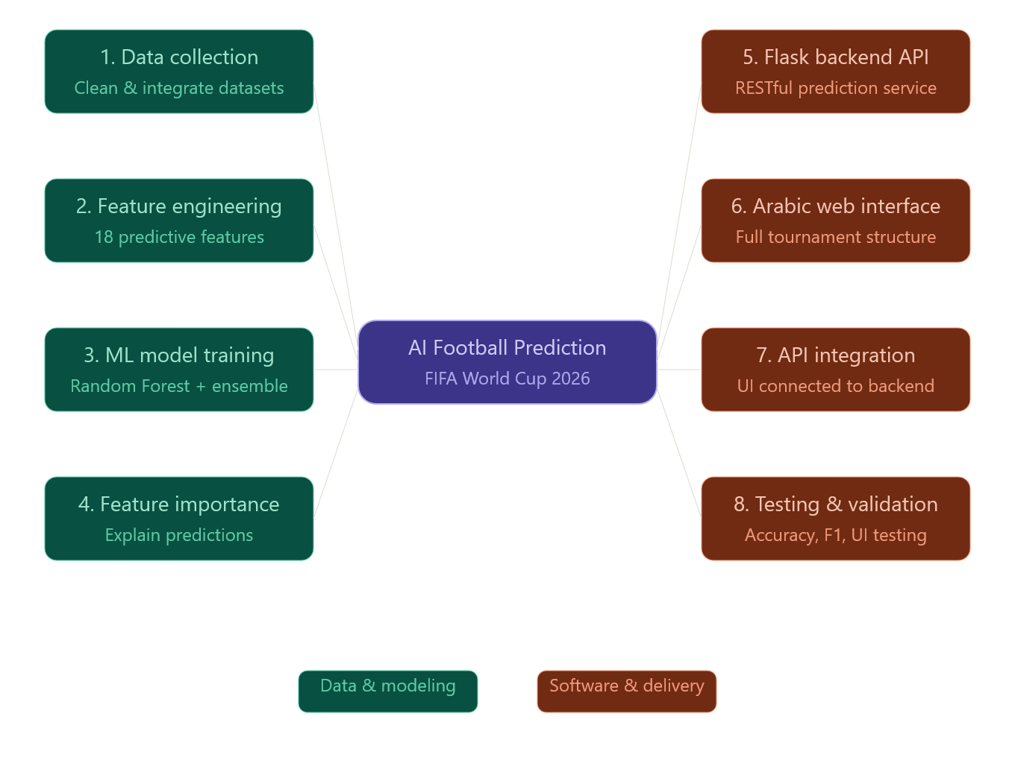

Figure 1.1 — Project Objectives Overview

1.5 Project Scope
The scope of this project defines the functional and operational boundaries of the proposed AI platform. It clarifies what the system is designed to do and, equally important, what falls outside its current responsibilities. Establishing this scope explicitly is essential for managing expectations and for ensuring that the available development time is invested in building a robust, focused, and demonstrable solution.

1.5.1 In Scope
The following capabilities are fully included within the scope of the proposed system:
- Collecting and integrating publicly available football datasets covering international match results, FIFA ranking history, penalty shootout outcomes, former country names, and EA Sports FC 26 player attributes.
- Performing a complete data cleaning and harmonization process, including filtering matches from January 2010 onward, unifying inconsistent team naming conventions across sources, removing matches with missing or unreliable information, and producing a final clean dataset of approximately 8,221 international matches.
- Implementing a feature engineering layer that derives eighteen predictive features from the cleaned data, including FIFA ranking differential, recent form for both teams, head-to-head ratio, average goals scored and conceded, tournament weight, and neutral-ground indicator.
- Training a dual-model architecture combining a Voting Ensemble (Random Forest + XGBoost + Logistic Regression) for win/loss prediction with a dedicated draw-detection model on the most competitive subset of matches, namely qualification matches and major continental and intercontinental tournament matches, and producing a serialized model that can be loaded directly by the prediction service.
- Building a Flask-based RESTful backend that loads the trained model, accepts JSON requests, retrieves up-to-date statistics for the requested teams, computes the corresponding feature vector, and returns probability-based prediction responses.
- Designing and implementing an interactive Arabic-language web interface that displays the full FIFA World Cup 2026 structure, including the twelve groups of the group stage, the daily fixture calendar with stadium information, the knockout bracket from the Round of 32 through the final, and the per-match prediction screen with class probabilities, confidence level, and a dynamic probability chart.
- Producing comprehensive technical documentation covering data preparation, feature engineering, model training and evaluation, backend implementation, frontend implementation, and end-to-end integration testing.

1.5.2 Out of Scope
To keep the project focused and feasible within the available timeframe, the following items are explicitly excluded from the scope of the current implementation:
- Predicting the exact final score of a match, such as 2-1 or 3-0; the system limits itself to predicting the categorical outcome — home win, draw, or away win — together with the associated probabilities.
- Predicting individual player events such as goal scorers, assists, yellow cards, red cards, or substitution patterns.
- Live in-game prediction based on real-time match events; the platform predicts the result of a match before it is played, not minute-by-minute during the match.
- Real-time integration with commercial paid APIs such as Opta or Stats Perform; the project relies exclusively on open and freely available datasets.
- Mobile native applications for iOS or Android; the system is delivered as a responsive web application accessible through any modern web browser.
- Any form of betting, gambling, or financial transaction; the platform is intended strictly for analytical, educational, and entertainment purposes.
- User account management, authentication, payment processing, or social features; these elements are not required to demonstrate the core scientific contribution of the platform.
The system is designed with extensibility in mind. Several of the items listed as out of scope — such as exact-score prediction or live in-game updates — could be incorporated as future enhancements without requiring a fundamental redesign of the underlying architecture, which is presented in detail in the System Design chapter of this document.

1.6 Target Users and Beneficiaries
The proposed AI Football Match Prediction & Analysis platform is designed to serve a broad range of users with different levels of technical expertise and different motivations for engaging with football data. The following groups represent the primary target users and beneficiaries of the system:

Football Fans and General Audience
Football fans constitute the largest target group of the platform. The FIFA World Cup attracts billions of viewers, and a significant portion of them actively engage in pre-match discussions, predictions, and friendly competitions with friends and family. The platform offers these users an accessible, scientifically grounded alternative to opinion-based predictions and provides them with a clear visual representation of the tournament structure, the daily fixture list, and the probability of each possible outcome. Through its intuitive Arabic-language interface, it lowers the barrier of entry for non-technical users and allows them to enjoy the analytical experience without prior knowledge of statistics or Machine Learning.

Sports Analysts and Football Journalists
Sports analysts, football journalists, and content creators benefit from the platform as a complementary analytical tool. Instead of relying solely on personal intuition or partial statistics, they can use the system to obtain quantitative, probability-based predictions to enrich their analyses, to validate or challenge their initial expectations, and to support their narratives with reproducible evidence. The probability-based output of the system — showing win, draw, and loss percentages — provides analysts with quantitative evidence to support their narratives and produce data-driven articles and broadcast segments.

Students and Researchers in Data Science
Students and researchers in Data Science, Artificial Intelligence, and sports analytics constitute another important beneficiary group. The platform serves as a concrete and well-documented case study that illustrates the full Machine Learning pipeline applied to a real-world domain: from raw data collection and cleaning, through feature engineering and model selection, to deployment via a web service and integration with an interactive frontend. The project's documentation and accompanying notebooks can serve as a reference for similar academic projects in the field.

Coaching Staff and Football Federations
Although the system is not designed as a professional decision-support tool for elite-level coaching staff, its analytical output may still be of interest to football federations, junior coaching teams, and amateur clubs that wish to study the relative strengths and weaknesses of competing national teams. By providing a structured comparison of teams across multiple dimensions, the platform can act as a starting point for more detailed scouting and tactical analysis.

Educators and Academic Supervisors
Finally, the platform also benefits the academic community, including instructors and supervisors of Data Science and Software Engineering courses. The combination of a complete data engineering pipeline, a non-trivial Machine Learning model, a backend service, and a fully integrated frontend makes it suitable as a reference example for teaching end-to-end AI system development, particularly in courses that focus on applied Machine Learning, software architecture, or capstone project methodology.
Across all of these user groups, the common benefit offered by the platform is the same: replacing isolated, opinion-based, or fragmented football predictions with a unified, transparent, and scientifically grounded analytical experience built on top of more than a decade of historical international football data.

CHAPTER 2: System Analysis

2.1 Introduction
System analysis is a foundational phase of the software development life cycle, during which the problem domain is studied in depth, the available data sources are evaluated, and the requirements of the proposed system are defined precisely. In data-driven projects such as the one presented in this document, this phase becomes especially important because the quality of the final predictions depends directly on the quality of the data, the appropriateness of the selected algorithm, and the rigor of the methodology that guides the work.
This chapter presents a comprehensive analysis of the AI Football Match Prediction & Analysis platform. It begins with a discussion of the data collection process and the sources from which the historical football data was obtained. It then describes the methodology adopted for developing the system, justifying the choice of a hybrid approach that combines the Cross-Industry Standard Process for Data Mining (CRISP-DM) for the data and modeling work with Agile principles for the web application development. The chapter then provides an in-depth comparative analysis of the candidate machine learning algorithms that were considered, explaining in detail why Random Forest was selected over alternatives such as Logistic Regression, Support Vector Machines, XGBoost, and Neural Networks. A dedicated section discusses the theoretical and empirical limits of football match prediction, contextualizing achieved competitive accuracy on three-class outcome prediction within the established research literature. The chapter continues with a review of the most relevant prior work on football outcome prediction, introduces the tools and technologies used during the implementation, and concludes with a detailed list of the functional and non-functional requirements that the system must satisfy.
The goal of this analysis is to ensure that every component of the proposed platform is grounded in a clear understanding of the problem, supported by reliable data, aligned with established research practices, and built on a solid technological foundation.

2.2 Data Collection and Sources
Building an accurate football match prediction model requires a large, reliable, and well-structured collection of historical data. Given that the proposed system aims to predict the outcomes of matches in the FIFA World Cup 2026, the data sources had to satisfy three essential conditions. First, they had to cover a sufficiently long historical period to capture the long-term performance trends of national teams. Second, they had to include information on every dimension of a football match that the model needs to consider, including teams, scores, dates, tournament types, FIFA rankings, and post-match outcomes such as penalty shootouts. Third, they had to be publicly available, frequently updated, and of high quality, in order to make the project both reproducible and ethically sound.
To meet these requirements, several open-access datasets published on Kaggle and other public data platforms were carefully selected, downloaded, and integrated into the project. Each dataset was chosen because it covers a specific dimension of the problem that none of the other sources could provide on its own. The combination of these complementary sources produces a unified, multidimensional view of every match in the dataset.

2.2.1 International Match Results Dataset
The primary dataset used in this project is the International Football Results dataset, which contains the detailed records of international football matches between national teams. The original dataset includes a total of 49,071 matches, dating from the very first international match in the late nineteenth century up to early 2026. For each match, the dataset records the date, the names of the home and away teams, the home and away scores, the type of tournament, the city and country in which the match was played, and a flag indicating whether the match was played on neutral ground. This dataset forms the backbone of the project; every feature ultimately derived for the model is computed by aggregating, comparing, or transforming records from this dataset.

2.2.2 FIFA Ranking History Dataset
The strength of a national team at a given point in time is one of the most important predictors of match outcomes. To capture this strength in a quantitative and time-aware manner, the project uses the FIFA Ranking History dataset, which contains weekly snapshots of the official FIFA rankings of every national team. For each ranking date, the dataset records the rank, the total points, the previous points, the rank change, and the confederation of every team. Crucially, the dataset enables the system to retrieve the FIFA ranking that was actually in effect on the date of every historical match, instead of using the current ranking, which would introduce serious temporal data leakage and produce misleading predictive performance.

2.2.3 Penalty Shootouts Dataset
In knockout-stage football matches, draws after regulation and extra time are typically resolved by a penalty shootout. The Penalty Shootouts dataset records the result of every shootout that has taken place in international competitions, including the date of the match, the names of the two teams, and the team that won the shootout. This dataset is essential because, without it, the model would treat shootout matches as plain draws, which would distort the computation of the form and historical performance features for the teams involved.

2.2.4 Former Country Names Dataset
Football has a long history, and during the past century many countries have changed their names due to political, geographical, or organizational reasons. The Former Country Names dataset provides a mapping between historical names and their modern equivalents. This mapping is applied during the data cleaning stage to ensure that all matches involving a given national team are correctly attributed to that team across the entire dataset, regardless of the name that was officially used at the time of the match.

2.2.5 EA Sports FC 26 Player Attributes Dataset
In addition to team-level historical performance, the project also explored individual player quality as a possible explanatory factor. To represent player strength, the EA Sports FC 26 player attributes dataset was used. This dataset contains the official player ratings published in the latest edition of the popular football simulation game produced by EA Sports, including the overall rating of each player as well as their detailed attributes such as pace, shooting, passing, dribbling, defending, and physicality. Player attributes were aggregated by national team in order to compute team-level rating averages, which were Player attributes were aggregated by national team and integrated into the final feature set used by the prediction model.

2.2.6 World Cup Top Scorers and Goalscorers Datasets
Two additional datasets, namely the World Cup Top Scorers dataset and the Goalscorers dataset, were also collected and cleaned. These datasets list the top historical goal scorers of the FIFA World Cup and the individual scorers of every recorded international goal. While these datasets are not directly used by the predictive model, they were processed to support detailed exploratory data analysis and to enable future extensions of the system that incorporate scorer-level features.

2.3 System Development Methodology
The choice of the development methodology has a direct effect on the quality, organization, and reproducibility of any software project. In the case of the proposed AI Football Match Prediction & Analysis platform, the methodology had to address two distinct types of work that coexist within the same project. The first type concerns the data engineering and modeling pipeline, where raw football data is collected, cleaned, transformed into engineered features, fed into a machine learning algorithm, and evaluated against quantitative performance metrics. The second type concerns the development of the backend service and the interactive web interface, which involves classical software engineering activities.
Because these two types of work follow different rhythms and require different mindsets, no single classical methodology was sufficient on its own. A hybrid methodology was therefore adopted, combining the Cross-Industry Standard Process for Data Mining (CRISP-DM) for the data and modeling pipeline with Agile principles for the software development of the backend and frontend.

2.3.1 CRISP-DM for the Data and Modeling Pipeline
CRISP-DM is the most widely adopted methodology for data mining and applied machine learning projects. It was originally developed in the late 1990s by a consortium of industry leaders including SPSS, Daimler-Benz, and NCR, and remains today the de facto standard for organizing data science work in academic and industrial settings. CRISP-DM divides any data-driven project into six phases that flow into one another, while still allowing iterative refinement when new insights are discovered along the way.
The six phases of CRISP-DM, as applied to the present project, are the following:
- Business Understanding — defining the prediction problem from the perspective of the end user. In our case, this corresponds to the need for transparent, probability-based predictions of FIFA World Cup 2026 matches that can replace subjective opinion-based forecasts.
- Data Understanding — collecting, exploring, and validating the source datasets. In our case, this corresponds to the inspection of the international results dataset, the FIFA ranking history, the shootouts dataset, the former names mapping, and the EA Sports FC 26 player ratings.
- Data Preparation — cleaning, harmonizing, filtering, and engineering features from the raw data. In our case, this corresponds to the entire cleaning notebook, including unifying team naming conventions, removing matches with missing scores, attaching the correct historical FIFA ranks to every match, integrating shootout outcomes, and computing the eighteen engineered features.
- Modeling — selecting and training one or more candidate algorithms. In our case, several algorithms were compared, and Random Forest was selected as the primary algorithm based on the comparison presented in Section 2.4.
- Evaluation — assessing the trained model against the project goals using rigorous quantitative metrics. In our case, the final model was evaluated using accuracy, per-class precision, recall, and F1-score on a held-out test set.
- Deployment — making the trained model available for real use. In our case, this corresponds to the serialization of the model into a portable file and its integration into the Flask backend that powers the web interface.

2.3.2 Agile Principles for Web Application Development
While CRISP-DM is well-suited for the data and modeling work, the development of the Flask backend and the JavaScript frontend follows a different rhythm that is better aligned with Agile software development principles. Agile development is based on iterative delivery, frequent feedback, and incremental refinement of working software. Instead of attempting to design and build the entire web interface in a single monolithic effort, the work was organized into short development cycles, each focused on adding a specific functional capability and on validating it through hands-on usage before moving to the next.

2.3.3 Justification of the Hybrid Methodology
Combining CRISP-DM with Agile principles offers the best of both worlds for a project of this nature. CRISP-DM provides the rigor, traceability, and structure that are essential when working with data and machine learning, where small mistakes in data cleaning or feature engineering can produce large errors in the final predictions. Agile, on the other hand, provides the flexibility and responsiveness that are essential when developing user-facing software, where the visual design and the user experience need to be tested and refined repeatedly. By assigning CRISP-DM to the data and model pipeline, and Agile principles to the application development, the project achieves a clear separation of concerns.

2.3.4 Development Timeline
The project was developed over the course of approximately four months, beginning in February 2026 and concluding in May 2026. The work was organized into sequential phases that mirror the structure of the hybrid methodology, with overlap between phases where appropriate. Each phase produced concrete deliverables that fed into the subsequent phases.
- Requirement Analysis and Project Planning — defining the problem, gathering data sources, and producing the initial project description.
- Data Collection and Exploration — downloading, inspecting, and validating the raw datasets from Kaggle and related public sources.
- Data Cleaning and Preparation — implementing the cleaning notebook to produce the unified dataset of 8,221 matches.
- Feature Engineering — designing and computing the eighteen predictive features used by the model.
- Algorithm Comparison and Model Training — running multiple experiments comparing several candidate algorithms and selecting the final model.
- Backend Development — implementing the Flask API that serves predictions in real time.
- Frontend Development — designing and implementing the interactive Arabic-language web interface.
- System Integration and Testing — connecting the frontend to the backend, validating end-to-end workflows, and fixing any defects.
- Documentation and Final Delivery — preparing the technical documentation and the final project package.

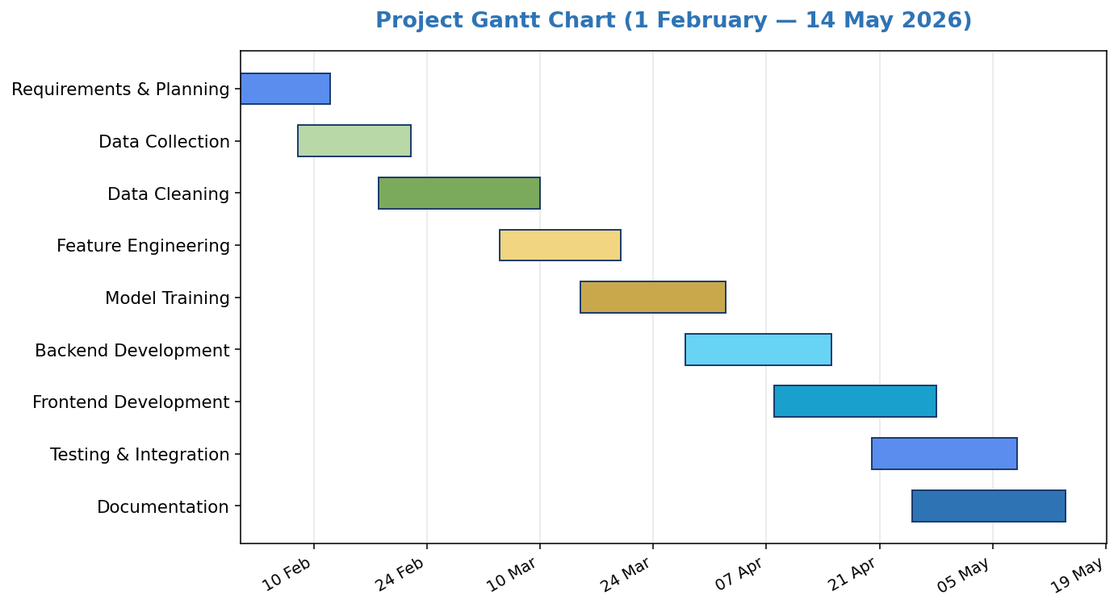
Figure 2.1 — Project Gantt Chart

2.4 Algorithm Selection and Justification
Selecting the appropriate machine learning algorithm is one of the most critical decisions in any predictive modeling project. The choice has a direct impact on the predictive accuracy, the training and inference speed, the interpretability of the predictions, the robustness of the system to noisy and imbalanced data, and the practical feasibility of deployment. In this project, the choice of algorithm received particular attention because the problem of football outcome prediction has very specific characteristics that make some algorithms a much better fit than others.
This section presents a structured comparison of the five most relevant candidate algorithms that were considered for the task, namely Logistic Regression, Support Vector Machines, Random Forest, Extreme Gradient Boosting (XGBoost), and feed-forward Neural Networks. Each algorithm is examined on its strengths, its weaknesses, and its suitability for the specific characteristics of our dataset and problem. The section concludes with an explicit justification of the choice of Random Forest as the primary algorithm of the system.

2.4.1 Characteristics of the Football Prediction Problem
Before comparing algorithms, it is important to make explicit the technical characteristics of the football match prediction problem, because these characteristics drive the suitability of each candidate algorithm. The problem presents the following nine defining properties:
- It is a multi-class classification problem with three mutually exclusive outcomes: home win, draw, and away win.
- The dataset is moderate in size, with 8,221 cleaned matches and only 2,343 matches in the most competitive subset on which the final model is trained.
- The features are entirely numerical and tabular, with no images, audio, or unstructured text.
- The project initially engineered eighteen predictive features derived from historical football data, including ranking differentials, recent form indicators, head-to-head statistics, scoring averages, and tournament context. After experimentation and feature evaluation, All eighteen engineered features were used in the final production model in order to reduce redundancy and improve model stability.
- The relationship between features and outcomes is non-linear and involves complex interactions; for example, the effect of recent form on the outcome may depend heavily on the FIFA ranking differential and on the importance of the tournament.
- The class distribution is imbalanced, with home wins, draws, and away wins occurring in different proportions.
- The problem has a substantial irreducible randomness component, because football outcomes are influenced by chance events, individual player decisions, and refereeing that cannot be predicted from historical statistics.
- Interpretability is highly desirable, because users want to understand why a particular outcome is more likely.
- The system must produce calibrated probability estimates rather than only categorical predictions, because the user interface needs to display win, draw, and loss probabilities.
These nine properties together rule out some algorithms and favor others, as detailed in the comparative analysis below.

2.4.2 Candidate Algorithms Summary
Several candidate algorithms were considered, including Logistic Regression, Support Vector Machines, XGBoost, and Neural Networks. Logistic Regression was useful as a simple baseline but was limited by its linear assumptions. SVMs can model non-linear decision boundaries, but they require careful tuning and do not naturally provide probability estimates. XGBoost is a strong tree-based competitor, but it is more sensitive to hyperparameter tuning on small datasets. Neural Networks were not preferred because the available training set is moderate in size and tabular, where tree-based models are usually more stable and easier to interpret.

2.4.3 Random Forest Selection Justification
Random Forest was initially selected as the primary baseline model because of its strong performance on numerical tabular data, its ability to capture non-linear feature interactions, its resistance to overfitting, and its support for feature importance analysis. The model achieved strong and stable performance during the early experimentation phase and served as the foundation for the system design.
However, because football match prediction — and especially draw prediction — is inherently difficult, the final system architecture was later extended into a hybrid ensemble approach. The production version of the platform combines a Voting Ensemble model consisting of Random Forest, XGBoost, and Logistic Regression for win/loss classification, together with a dedicated draw-detection model designed specifically to improve draw recognition performance.
This hybrid architecture preserves the interpretability and robustness advantages of Random Forest while benefiting from the complementary strengths of additional algorithms. The final design therefore provides a better balance between predictive performance, probability calibration, and practical usability within the context of international football prediction.

2.4.4 Comparative Summary Table
Table 2.1 below summarizes the comparison among the five candidate algorithms across the seven evaluation criteria that matter most for the present project.

Table 2.1 — Comparison of Candidate Algorithms
Criterion | Logistic Regression | SVM | Random Forest | XGBoost | Neural Networks
Captures non-linearities | No | Yes | Yes | Yes | Yes
Works well on small data | Yes | Moderate | Excellent | Good | Poor
Native probability output | Yes | Requires Platt scaling | Yes | Yes | Yes
Handles class imbalance natively | Partial | Partial | Yes | Yes | Manual
Interpretability | High | Low | High | Moderate | Very Low
Hyperparameter tuning effort | Minimal | High | Low | High | Very High
Overall fit for our problem | Weak | Moderate | Excellent | Good | Poor

As Table 2.1 shows, Random Forest provides the best overall balance for this project: strong performance on tabular data, support for non-linear relationships, probability outputs, class weighting, and practical interpretability through feature importance scores.

2.5 Understanding Accuracy in Football Prediction
A natural question that arises when evaluating any predictive model is whether the achieved accuracy is good or bad in absolute terms. For many classification problems in computer science, an accuracy of around 61% would be considered modest. However, in the specific domain of football match prediction, this figure tells a very different story. This section explains the technical reasons why an accuracy in the low to mid sixties is in fact a strong result for three-class football outcome prediction, and why the literature consistently reports figures in this range as the practical state of the art.

2.5.1 The Theoretical Ceiling of Football Prediction
Football is among the most unpredictable team sports, both in absolute terms and in comparison to other major sports such as basketball, American football, and ice hockey. There are five well-documented reasons for this inherent unpredictability:
- Low scoring rate: most football matches end with a total of two or three goals only, and a very large fraction end either zero-zero or one-zero. With so few scoring events per match, single moments of luck — a deflected ball, a lucky bounce, an offside decision — can determine the entire outcome.
- High variance of individual events: in football, the probability that a given shot becomes a goal is typically below ten percent, which means that the conversion of attacking dominance into actual goals is itself a noisy process.
- Refereeing decisions: a single decision regarding a penalty, an offside, a red card, or a goal-line technology call can change the entire course of the match in ways that no statistical feature can anticipate.
- Player-level variability: form fluctuations, injuries during the match, and the personal motivation of key players cannot be fully captured by team-level features.
- Tactical surprises: a coach can deploy an unexpected formation or game plan that fundamentally changes the dynamics of the match relative to historical expectations.
These five sources of randomness imply that there is a non-trivial irreducible error in football match prediction, regardless of how sophisticated the model is or how rich the feature set becomes. Researchers in the field generally estimate that the upper bound of three-class football prediction accuracy lies somewhere between 65% and 75%, depending on the league and the time period, and that any model claiming higher accuracy is most likely either overfitting or evaluating on an unrealistically simple test set. This irreducible error is often referred to as the Bayes error of the problem and represents the fundamental ceiling that no model can exceed.

2.5.2 Comparison with Random and Majority-Class Baselines
Two natural baselines provide a useful reference point for any classification model. The first is the random baseline, which assigns each class with a probability proportional to its prevalence. For our problem, with class proportions of approximately 47% home wins, 29% away wins, and 23% draws on the competitive subset, the random baseline would achieve an accuracy of roughly 35%. The second is the majority-class baseline, which always predicts the most frequent class, namely home wins. This baseline would achieve an accuracy of approximately 47%, which is mathematically equal to the proportion of home wins in the test set.
Our trained Voting Ensemble model achieves an accuracy of 61.62%, which represents an absolute improvement of 27 percentage points over the random baseline and 15 percentage points over the majority-class baseline. In relative terms, the model is approximately 76% more accurate than random guessing and approximately 31% more accurate than always predicting home wins. These improvements are large and statistically meaningful, and they constitute clear evidence that the model has successfully learned predictive patterns from the data.

Table 2.2 — Comparison with Baselines
Approach | Accuracy | Improvement vs Random
Random guessing (proportional) | ≈ 35% | Baseline
Majority class (always home win) | ≈ 47% | +12 points
Our Voting Ensemble model | 61.62% | +27 points
Theoretical ceiling (Bayes error) | ≈ 65–75% | Practical upper bound

2.5.3 Comparison with Published Football Prediction Studies
Beyond the simple baselines, the most informative way to evaluate the accuracy of a football prediction model is to compare it against the figures reported in peer-reviewed academic studies on similar tasks. Table 2.3 below summarizes the accuracies reported in several well-known studies in the field.

Table 2.3 — Reported Accuracies in Football Prediction Literature
Study | Domain | Algorithm | Accuracy
Prasetio & Harlili (2016) | English Premier League | Random Forest | 68.55%
Prasetio & Harlili (2016) | English Premier League | XGBoost | 67.89%
Prasetio & Harlili (2016) | English Premier League | C5.0 Decision Tree | 64.87%
Beal et al. (2020) | EPL (with NLP previews) | Hybrid ML + NLP | 63.18%
Hubáček et al. (2019) | European football | Probabilistic ML | ≈ 52–58%
Liu (2024) | FIFA World Cup | Random Forest | ≈ 60–65%
Atta Mills et al. (2024) | World Cup (international) | Random Forest | ≈ 60%
Our system | FIFA World Cup 2026 (international) | Random Forest | 61.62%

Table 2.3 reveals two important observations. First, the published accuracies are clustered between approximately 55% and 70%, with most studies reporting values in the low to mid sixties. The accuracy of 61.62% achieved by our system falls right in the middle of this established range, demonstrating that the system is competitive with peer-reviewed academic work on the same task. Second, the studies that focus specifically on international football and the FIFA World Cup, rather than on domestic leagues, tend to report lower accuracies in the 60% range, because international football is intrinsically harder to predict than club football. The reason is that national teams play far fewer matches than club teams, the squads change frequently between matches, and the players come from many different clubs and tactical systems. Our accuracy of 61.62% is therefore at the upper end of what is realistically achievable for international football prediction.

2.5.4 Why International Football Is Harder Than Club Football
Most published football prediction studies focus on domestic leagues such as the English Premier League, where the same teams play one another twice per season under stable squad and tactical conditions. International football, by contrast, presents three additional challenges that reduce the achievable accuracy.
- Lower match frequency: a national team plays only ten to fifteen matches per year, compared to thirty-eight or more for a typical club team in a top European league. This sparse data makes it harder for the model to track current team strength accurately.
- Squad volatility: the players selected for a national team can change substantially from one match to the next, depending on availability, injuries, and the coach's preferences. This volatility means that the team that played the last match is not exactly the team that will play the next match.
- Tactical heterogeneity: national-team players come from a wide variety of clubs and tactical systems, and the limited preparation time before each match makes it harder for the team to develop the kind of cohesion that club teams build over a full season.
These three additional challenges explain why our accuracy of 61.62% should not be compared directly to studies on the English Premier League, where some authors report numbers as high as 68% or 70%. Within the more demanding domain of international football, our result is fully aligned with the state of the art.

2.5.5 Why Accuracy Alone Is Not the Only Metric
Accuracy is the most intuitive evaluation metric, but in football prediction, where the problem is multi-class and the class distribution is imbalanced, additional metrics provide a richer view of model quality. The system was therefore evaluated using four complementary metrics: accuracy, per-class precision, per-class recall, and per-class F1-score. The balance among these metrics is at least as important as the headline accuracy number, because a model that achieves high accuracy by always predicting home wins would be useless in practice, even though its accuracy could appear acceptable.
In addition, the system produces full probability distributions over the three classes, which allows users to interpret the confidence of each prediction. A match where the model assigns 70% probability to a home win is qualitatively different from a match where the model assigns 38% probability to a home win, even though the categorical prediction is the same. Probability calibration of this kind is highly valued in the football prediction literature, where metrics such as the Ranked Probability Score (RPS) and logarithmic loss are explicitly designed to reward well-calibrated probability estimates. The detailed evaluation results, including confusion matrices and per-class metrics, are presented in Chapter 4 of this document.

2.6 Related Work and Literature Review
The application of Machine Learning to the prediction of football match outcomes is an active research area. Many academic studies have explored different algorithms, feature sets, leagues, and tournaments, and have reported a wide range of accuracies depending on the experimental conditions. Reviewing this prior work provides three benefits to the present project. First, it confirms that the choice of Random Forest as the primary algorithm is consistent with the best practices identified in the literature. Second, it places the achieved accuracy of the proposed model in context. Third, it identifies the gaps in existing work that the proposed platform attempts to address. The five studies summarized below are particularly relevant to the present project.

2.6.1 Liu (2024) — FIFA World Cup Prediction with Random Forests
Liu (2024) proposed a football match prediction system based on FIFA rankings and international football match data spanning from 1872 to 2018. The author applied feature engineering to derive predictive variables from the raw match records and trained a Voting Ensemble model to predict match outcomes. The study was specifically aimed at the FIFA World Cup, and the trained model was used to forecast the winning team of the 2018 edition of the tournament. The reported results demonstrate that the Random Forest algorithm is well-suited for World Cup match prediction, especially when combined with carefully engineered ranking-based features. The proposed project shares the same algorithmic foundation as Liu's work, while extending it to the upcoming FIFA World Cup 2026 and embedding it inside a complete interactive web platform that supports per-match prediction and visualization.

2.6.2 Prasetio and Harlili (2016) — Tree-Based Models on EPL Data
Prasetio and Harlili (2016) presented a comparative study of tree-based machine learning algorithms applied to football match prediction. The authors compared C5.0, Random Forest, and Extreme Gradient Boosting on ten seasons of English Premier League data, using a backward wrapper feature selection method to identify the most informative subset of features. They reported that Random Forest achieved the highest accuracy at 68.55%, outperforming both C5.0 (64.87%) and Extreme Gradient Boosting (67.89%). This study provides empirical evidence for the strong performance of Random Forest on football prediction tasks, and supports the choice of Random Forest as the primary algorithm in the present project.

2.6.3 Hubáček, Šourek, and Železný (2019) — Probabilistic Soccer Prediction
Hubáček et al. (2019) proposed a probabilistic framework for predicting soccer results, applying machine learning techniques to a large dataset of European football matches. The authors emphasized the importance of probabilistic outputs over single-point predictions, arguing that probability estimates carry richer information for downstream applications such as decision support and analytical commentary. They also highlighted the role of evaluation metrics that go beyond plain accuracy, such as the Ranked Probability Score (RPS) and logarithmic loss, which penalize poorly calibrated predictions. The proposed system in the present project adopts the same philosophy by exposing the full probability distribution over the three possible outcomes.

2.6.4 Groll, Ley, Schauberger, and Van Eetvelde (2019) — Hybrid Random Forest with Poisson Ratings
Groll et al. (2019) proposed a hybrid prediction approach in which a Random Forest classifier is combined with team strength estimates derived from a Poisson regression model. They demonstrated that this hybrid approach outperforms standard statistical models when applied to international football tournaments, and they used their model to forecast the outcomes of the FIFA World Cup. Their work confirms that Random Forest is a particularly competitive algorithm for World Cup prediction. The proposed project adopts a related strategy: instead of relying on Poisson-based team ratings, it engineers eighteen features that collectively capture the relative strength of the two teams from multiple complementary angles.

2.6.5 Atta Mills, Mwangi, and Mensah (2024) — Random Forest vs Gradient Boosting
Atta Mills et al. (2024) introduced a soccer match prediction framework that jointly applies Random Forest and Gradient Boosting models to historical international match data, with the explicit goal of forecasting the next FIFA World Cup. They evaluated the two models using multiple performance metrics including precision and accuracy, and concluded that the Random Forest approach outperformed the Gradient Boosting approach on this particular task. They also used the feature importance scores produced by the Voting Ensemble model to identify the variables that contribute most strongly to the prediction. The present project follows the same overall direction by adopting Random Forest as its primary algorithm, but contributes additional value by combining the trained model with a fully interactive web interface that exposes the predictions to the end user.

2.6.6 Comparative Summary and Research Gap
Taken together, these five studies establish a clear consensus in the literature on three points. First, Random Forest is one of the most consistently effective algorithms for football match outcome prediction, frequently outperforming both simpler statistical models and more complex deep learning approaches when the dataset size is moderate. Second, careful feature engineering is at least as important as the choice of algorithm. Third, the typical accuracies reported on three-class football prediction tasks are clustered between approximately 55% and 70%, with international football specifically hovering around 60%.
At the same time, all five reviewed studies share a common limitation: they focus exclusively on the modeling and prediction aspects of the problem, and do not provide an end-user platform that allows non-technical users to explore predictions interactively. The present project addresses this gap by combining a competitive Voting Ensemble model with a fully integrated web interface that displays the entire FIFA World Cup 2026 structure, supports per-match prediction with class probabilities, and visualizes the results through dynamic charts.

2.7 Tools and Technologies
The implementation of the proposed system relies on a carefully selected stack of programming languages, libraries, and tools. The chosen technologies were favored because of their widespread adoption in the data science and web development communities, their strong documentation, their open-source nature, and their proven track record in academic and industrial projects.

2.7.1 Programming Languages and Core Libraries
Python 3 was selected as the primary programming language for the data engineering, modeling, and backend layers of the system. Python is the de facto standard language for data science and machine learning projects, and it offers a rich ecosystem of mature libraries that cover every stage of the data analysis pipeline. The Pandas library was used extensively for tabular data manipulation, including loading the raw datasets from CSV files, filtering rows by date or by team, joining datasets on common keys, and saving the cleaned data back to disk. The NumPy library provided the underlying numerical computation primitives required by Pandas and by the machine learning algorithms.

2.7.2 Machine Learning Libraries
The machine learning components of the system were implemented using the scikit-learn library, which is the most widely used machine learning library in the Python ecosystem. Scikit-learn provides production-quality implementations of classical machine learning algorithms, including the Random Forest classifier used in this project, along with utilities for splitting data into training and test sets, computing classification metrics, and handling class imbalance. The Pickle module from the Python standard library was used to serialize the trained model and the list of feature names into portable binary files. The XGBoost library was also used as one of the three estimators in the final Voting Ensemble model, providing a gradient boosting component that complements the Random Forest and Logistic Regression classifiers.

2.7.3 Backend Technologies
The backend service of the system was implemented using the Flask web framework. Flask is a lightweight, micro-framework for building web services in Python, and it is particularly well-suited for machine learning deployment scenarios where a single trained model needs to be exposed through a small number of well-defined endpoints. Flask was supplemented by the Flask-CORS extension, which enables Cross-Origin Resource Sharing and allows the JavaScript frontend to communicate with the backend even when the two are served from different origins during development.

2.7.4 Frontend Technologies
The user-facing interface of the system was implemented using the standard trio of web technologies: HTML5 for the structural markup, CSS3 for the visual styling, and JavaScript for the interactive behavior. No frontend framework such as React or Angular was used, in order to keep the dependency footprint minimal and to demonstrate that a polished and modern user interface can be delivered using only standard web technologies. The Chart.js library was used to render the dynamic probability bar chart that visualizes the prediction output. Custom CSS was written to produce a tournament-inspired visual identity, including the dark color palette, the gold and cyan accent colors, the gradient backgrounds, and the typography combining the Cairo and Bebas Neue font families. Country flags were retrieved at runtime from the FlagCDN public service.

2.7.5 Development Environment
The entire development process was carried out using Visual Studio Code as the integrated development environment, supplemented by Jupyter notebooks for the data exploration, cleaning, and modeling phases. Git was used for source control, with the project repository hosted on GitHub. The standard Python virtual environment mechanism was used to isolate the project dependencies, ensuring that the system can be reproduced on any machine with a compatible Python interpreter.

2.8 Functional Requirements
Functional requirements describe the specific behaviors and capabilities that the system must provide to its users. They define what the system does, in observable and testable terms. Based on the data collection and the methodology described above, and taking into account the target users identified in the previous chapter, the following functional requirements were established for the proposed AI Football Match Prediction & Analysis platform:
- The system shall load and process a unified, pre-cleaned dataset of historical international football matches, comprising at least 8,000 records spanning from January 2010 onward.
- The system shall compute eighteen engineered football-related features and select the final eighteen features subset used by the production prediction models, including FIFA ranking differential, recent form indicators, head-to-head statistics, tournament weight, scoring averages, and neutral-ground information.
- The system shall train a hybrid ensemble-based prediction architecture combining Random Forest, XGBoost, and Logistic Regression for win/loss classification, together with a dedicated draw-detection classifier optimized for football match prediction.
- The system shall persist the trained model and the corresponding list of features into binary files, so that they can be loaded directly by the backend service without being re-trained at every startup.
- The backend service shall expose a RESTful API endpoint that accepts the names of two teams in a JSON request body and returns a structured JSON response containing the predicted winning team, the probabilities of the three possible outcomes, and a confidence percentage.
- The backend service shall validate every incoming request and return an informative error message when one or both teams are missing from the historical dataset or when the request body is malformed.
- The frontend interface shall display the complete structure of the FIFA World Cup 2026, including the twelve groups of four teams each, the daily fixture calendar from June 11 to July 19, 2026, and the knockout bracket from the Round of 32 through the final.
- The frontend interface shall allow the user to navigate the tournament calendar day by day, in both forward and backward directions, and to jump to any specific date through an embedded date picker.
- The frontend interface shall display, for any selected match, a detailed prediction screen that includes the win, draw, and loss probabilities, the predicted winner, the model's confidence level, and an interactive bar chart visualizing the three probabilities.
- The frontend interface shall communicate with the backend service in real time and shall display informative messages to the user when a prediction request is being processed, when it has succeeded, or when it has failed.
- The frontend interface shall display a countdown timer to the kickoff of the FIFA World Cup 2026 and shall present the user with an introductory video that establishes the visual identity of the platform.
- The system shall remain fully usable on modern desktop and tablet web browsers without any additional installation, beyond starting the backend service on the host machine.

2.9 Non-Functional Requirements
Non-functional requirements describe the quality attributes of the system rather than its specific features. They define how the system should perform, how easy it should be to use, and how robust it should be against unexpected conditions.

Performance
The system shall return a prediction response for any valid request within one second under normal load conditions, in order to provide a smooth and responsive user experience. The model loading time at backend startup shall not exceed five seconds. The frontend interface shall render the group stage view, the knockout bracket, and the daily fixture calendar within two seconds of the initial page load on a typical broadband connection.

Usability
The user interface shall be designed in Arabic with right-to-left text orientation, in order to be accessible to the primary audience of Arabic-speaking football fans. The interface shall use a clean, modern visual style inspired by the official identity of the FIFA World Cup 2026, with consistent use of typography, color, and iconography. All interactive elements, including buttons, modals, and date pickers, shall provide clear visual feedback when activated.

Reliability
The system shall produce identical prediction results for identical input requests, ensuring full reproducibility of the predictions. The backend service shall handle malformed requests gracefully, returning informative error messages instead of crashing. The frontend interface shall handle backend communication failures gracefully, displaying a user-friendly message and offering the user the possibility of retrying the request.

Maintainability
The source code of the system shall be organized into modular components with clearly separated responsibilities, including a dedicated module for the data cleaning and feature engineering pipeline, a dedicated module for the model training, a dedicated module for the prediction logic, and a dedicated module for the Flask backend. All non-trivial functions shall be accompanied by short explanatory comments. The complete development history of the project shall be tracked in a Git repository hosted on GitHub.

Portability
The backend service shall be runnable on any operating system that supports Python 3, including Windows, Linux, and macOS, without modification. The frontend interface shall function correctly in any modern web browser, including Google Chrome, Mozilla Firefox, and Microsoft Edge. The serialized model file and the feature list file shall be portable across machines, so that the trained model can be shared and re-used without requiring access to the original training data or the original training environment.

CHAPTER 3: System Design

3.1 Introduction
This chapter presents the system design of the AI Football Match Prediction & Analysis platform. System design is the phase that transforms the requirements identified in Chapter 2 into a concrete technical blueprint that the development team can implement. In a project that combines a machine learning pipeline with a web application, design decisions must address two complementary questions: how the data flows from raw CSV files through the prediction model and back to the user interface, and how the responsibilities of the system are distributed across well-defined software components.
The design decisions documented in this chapter are guided by four overarching principles. First, separation of concerns: each module of the system is responsible for one well-defined task, and modules communicate through stable, simple interfaces. Second, reproducibility: the data pipeline must be deterministic, so that running it twice on the same input produces the same output. Third, testability: each component must be testable in isolation, so that defects can be detected early and fixed without affecting the rest of the system. Fourth, deployability: the final system must be packageable and runnable on any modern operating system without complex setup procedures.
This chapter is structured as follows. Section 3.2 presents the overall system architecture, describing the layered structure of the platform and the responsibilities of each layer. Section 3.3 details the data pipeline architecture, showing how raw datasets are progressively transformed into the final clean, feature-rich dataset that feeds the model. Section 3.4 documents the system using standard software engineering diagrams, including the use case diagram, the sequence diagram of the prediction workflow, and the data flow diagram. Section 3.5 specifies the design of the RESTful API exposed by the backend service. Section 3.6 describes the user interface design of the web application.

3.2 System Architecture Design
The proposed system follows a three-layer architecture that cleanly separates the user-facing presentation logic from the business logic of the prediction engine and from the underlying data assets. This architectural style was chosen because it is well-suited to data-driven web applications, because it scales naturally as the system grows, and because it allows each layer to be developed, tested, and updated independently of the others.

3.2.1 Architecture Overview
The system architecture is organized into three clearly defined layers, each with distinct responsibilities and communication boundaries.
- The Presentation Layer is the user-facing component of the platform, implemented as an interactive web application that runs entirely in the user's browser.
- The Application Layer hosts the business logic of the system, including the Flask backend, the prediction engine, the feature extraction utilities, and the data access functions.
- The Data Layer is the foundational layer that holds the cleaned historical match dataset, the engineered feature dataset, the trained Voting Ensemble model, and the auxiliary supporting files.
Communication between the layers follows a strict, well-defined protocol. The Presentation Layer never communicates directly with the Data Layer. Instead, it issues HTTP requests to the Application Layer, which is the only component authorized to read from the Data Layer and to invoke the trained model. This separation enforces a clean boundary between the user interface and the underlying data, and makes it possible to evolve the data layer (for example, by replacing CSV files with a database) without changing a single line of frontend code.

Figure 3.1 — Three-Layer System Architecture
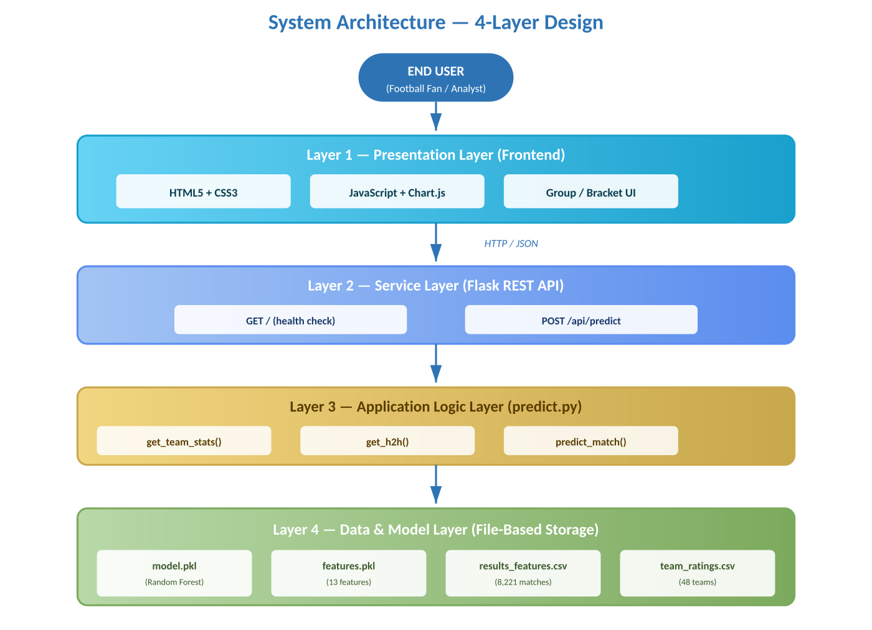

3.2.2 Presentation Layer
The Presentation Layer represents the entire user-facing surface of the platform. It is implemented as a single-page interactive web application built using HTML5, CSS3, and modern JavaScript, supplemented by the Chart.js library for dynamic chart rendering. The decision to implement the Presentation Layer using vanilla web technologies, without a heavy frontend framework such as React or Angular, was deliberate. It keeps the system lightweight, eliminates external build tooling, and demonstrates that a polished modern interface can be delivered with a small dependency footprint.
The responsibilities of this layer are the following:
- Rendering the visual structure of the FIFA World Cup 2026, including the twelve groups of the group stage and the complete knockout bracket from the Round of 32 to the final.
- Displaying the daily fixture calendar and allowing the user to navigate forward and backward through the tournament schedule.
- Capturing user interactions, including clicks on individual matches and the selection of the match outcome to predict.
- Issuing asynchronous HTTP requests to the Application Layer using the standard Fetch API.
- Receiving JSON responses from the backend and translating them into visually rich displays, including probability bar charts, confidence indicators, and predicted-winner highlights.
- Providing graceful loading states and error messages when communication with the backend takes time or fails.

3.2.3 Application Layer
The Application Layer is the heart of the system. It is implemented in Python using the Flask micro-framework and contains all the logic required to process a prediction request from start to finish. When the backend service starts, it loads the serialized Voting Ensemble model and the list of feature names into memory. From that point on, every incoming HTTP request is handled by a small, well-defined pipeline of operations.
The internal structure of the Application Layer can be decomposed into four sub-components:
- The HTTP Server Component, implemented using Flask and the Flask-CORS extension, accepts incoming requests on a configurable port, routes them to the appropriate handler function, and returns properly formatted JSON responses.
- The Request Validation Component checks that every incoming request contains valid team names, that both teams exist in the historical dataset, and that the request body is well-formed JSON.
- The Feature Extraction Component is responsible for retrieving the most recent statistics for each team from the historical dataset, computing the head-to-head ratio between them, and assembling the final eighteen-element feature vector selected from the original eighteen engineered features used during the feature engineering phase.
- The Prediction Component invokes the trained Random Forest model on the feature vector, retrieves the probability distribution over the three possible outcomes, identifies the most likely outcome, and packages the result into a structured response object.
This internal decomposition makes the Application Layer easy to test, easy to extend with new endpoints, and easy to evolve as the model is retrained or as new features are added.

3.2.4 Data Layer
The Data Layer holds all the persistent assets of the system. In the current implementation, the Data Layer is realized as a structured collection of files on disk, organized into two directories. The raw directory contains the original CSV datasets downloaded from public sources, including the international match results, the FIFA ranking history, the penalty shootouts, the former country names mapping, and the EA Sports FC 26 player attributes. The clean directory contains the processed and feature-rich datasets produced by the data preparation pipeline, including the unified results dataset, the engineered features dataset, the team ratings summary, and the squad data.
In addition to the CSV files, the Data Layer also stores three Python pickle files that are produced at the end of the modeling phase. The first pickle file contains the trained Random Forest model with all its three hundred decision trees. The second pickle file contains the ordered list of the eighteen feature names expected by the model, which the backend uses to construct feature vectors in the correct order. The third pickle file contains supplementary data structures that the prediction logic uses to enrich the response with team-level metadata.
The choice of a file-based data layer is appropriate for the current scale and use case of the project, because the historical match dataset is essentially read-only, the data volume is moderate, and there are no concurrent write operations. The architecture is nevertheless designed in such a way that the Data Layer could be replaced by a relational database in a future iteration without any change to the Presentation Layer and with only minimal changes to the Application Layer.

3.3 Data Pipeline Architecture
Beyond the runtime architecture described in the previous section, the system also has a parallel data pipeline architecture that governs how raw data is progressively transformed into a model-ready form. This pipeline runs offline and is not invoked at request time, but it is a fundamental part of the system because the quality of the predictions depends entirely on the quality of the data that comes out of it.

3.3.1 Pipeline Stages
The data pipeline consists of five sequential stages, each implemented as a dedicated section of a Jupyter notebook. The output of each stage becomes the input of the next stage, and intermediate results are persisted to disk so that any single stage can be re-executed without re-running the previous ones.
- Data Ingestion. In this stage, the raw CSV datasets are loaded into Pandas data frames using the pd.read_csv() function. Basic structural validation is performed to confirm that the expected columns are present and that the data types are correct.
- Data Cleaning. In this stage, the loaded data is filtered to retain only matches from January 2010 onward, matches with non-null scores, and matches involving teams that participate in international competitions relevant to the FIFA World Cup 2026. Inconsistent team names are unified using the former country names mapping, and a small number of manual name corrections are applied to handle source-specific quirks.
- Data Enrichment. In this stage, every match in the cleaned dataset is enriched with the FIFA ranking that was actually in effect on the date of the match, retrieved from the FIFA ranking history dataset. Penalty shootout outcomes are merged into the dataset so that knockout matches can be assigned a definitive winner. Tournament names are mapped to a four-level importance scale: friendly matches receive weight 1, qualifiers receive weight 2, continental tournaments receive weight 3, and the FIFA World Cup itself receives weight 4.
- Feature Engineering. In this stage, eighteen predictive features are computed for every match by aggregating information from previous matches of the two teams involved. Features include the FIFA ranking differential, the recent form of each team measured over its last five matches, the head-to-head ratio over the last ten encounters, the average number of goals scored and conceded by each team in their most recent matches, the importance weight of the tournament, and a flag indicating whether the match is played on neutral ground.
- Model Training and Persistence. In this final stage, the engineered features and the corresponding match outcomes are passed to a Random Forest classifier from scikit-learn. The classifier is trained, evaluated on a held-out test set, and serialized to disk as a pickle file together with the ordered list of feature names. The serialized model is then loaded by the backend service at startup and used to serve real-time predictions.
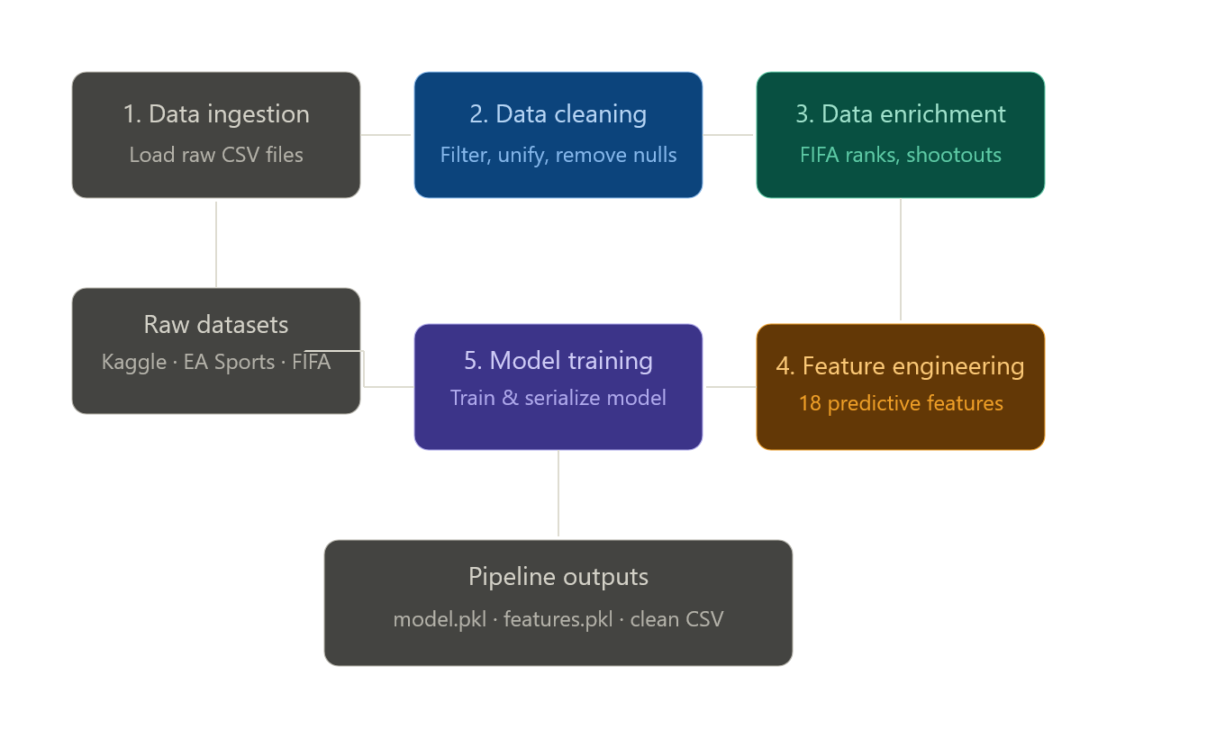

Figure 3.2 — Data Pipeline Stages
(Figure 3.2 will be inserted here, showing the five sequential stages of the data pipeline from raw CSV ingestion through to model serialization.)

3.3.2 Pipeline Outputs
At the end of the pipeline, three categories of artifacts are produced:
- The cleaned international match dataset, containing 8,221 matches spanning the period from 2 January 2010 to 26 January 2026, each annotated with the historical FIFA ranks of both teams, the tournament weight, and the final outcome (including shootout resolution where applicable).
- The engineered features dataset, containing the same 8,221 matches augmented with the eighteen predictive features required by the Random Forest model.
- The serialized model assets, comprising the trained Random Forest classifier, the ordered list of feature names, and the supporting metadata structures that the backend uses at runtime.
These three artifacts are the only inputs that the runtime system needs in order to serve predictions. The raw CSV datasets are no longer required at runtime, although they are retained in the repository for full reproducibility.

3.4 System Modeling
System modeling complements the architectural and pipeline descriptions presented in the previous sections by capturing the dynamic behavior of the platform using standard software engineering diagrams. Three diagrams in particular are used to model the system: a use case diagram that summarizes the functional capabilities of the platform from the user's perspective, a sequence diagram that traces the end-to-end flow of a prediction request, and a data flow diagram that shows how data moves through the system.

3.4.1 Use Case Diagram
The use case diagram identifies the primary actor of the system and enumerates the functional capabilities that this actor can exercise. In the case of the proposed platform, there is a single primary actor, namely the End User, who interacts with the platform through the web interface.
The end user can perform the following use cases:
- View the introductory video and the countdown timer to the FIFA World Cup 2026 kickoff.
- Browse the twelve groups of the group stage and inspect the four teams in each group.
- Navigate the daily fixture calendar from 11 June to 19 July 2026 in either direction.
- Jump to a specific date through the embedded date picker.
- Select a specific match from the daily fixture list.
- Request a prediction for the selected match.
- View the predicted outcome, the win, draw, and loss probabilities, the confidence level, and the probability bar chart.
- Browse the knockout bracket from the Round of 32 to the final.
- Select any match in the knockout bracket and request a prediction for it.

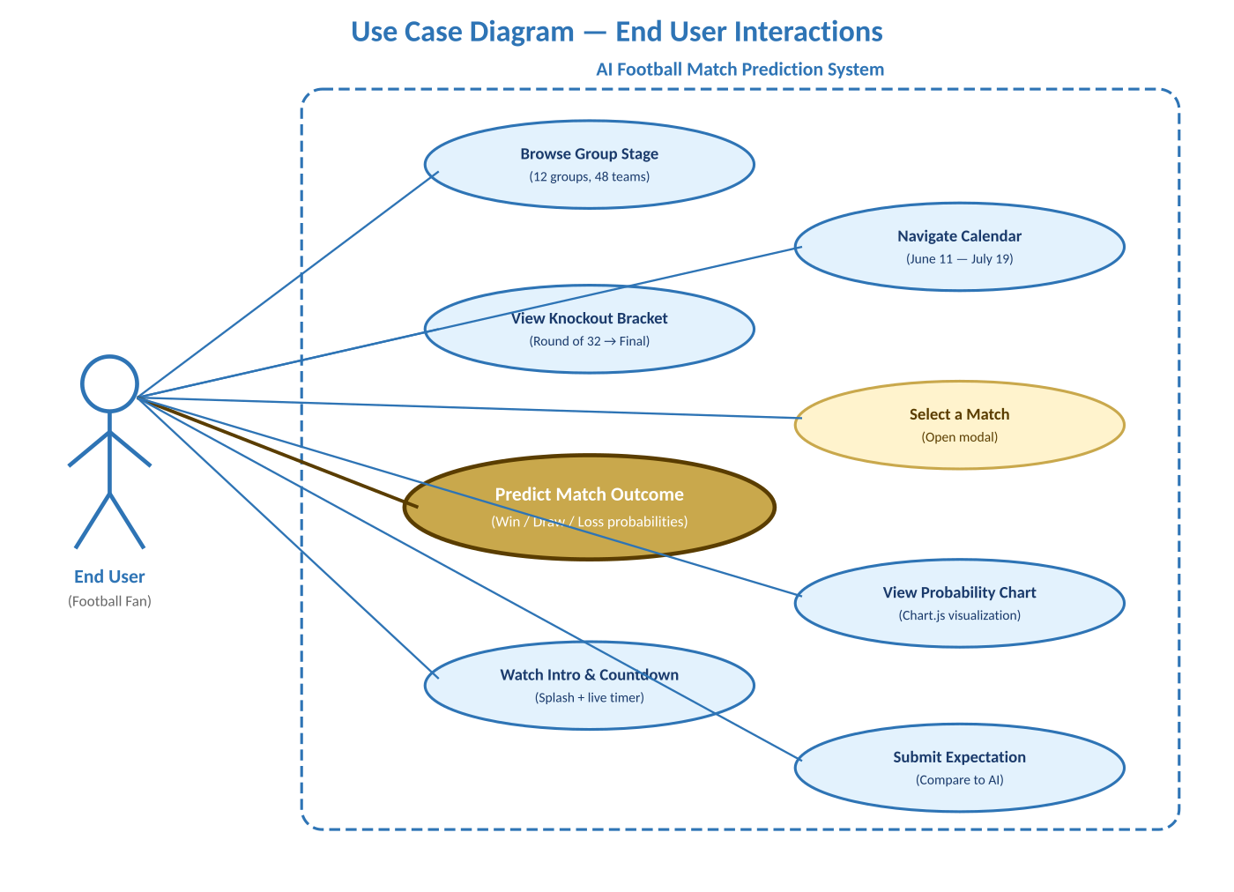
Figure 3.3 — Use Case Diagram

3.4.2 Sequence Diagram of the Prediction Workflow
The sequence diagram below traces the end-to-end interaction that takes place when an end user requests a prediction for a specific match. The diagram involves four participants: the End User, the Frontend (running in the browser), the Flask Backend, and the Random Forest Model. The interaction follows a strict request-response pattern that takes typically less than one second to complete from the user's click to the visual display of the prediction.
The complete sequence proceeds as follows:
- The End User clicks on a specific match in the group stage view or in the knockout bracket view.
- The Frontend opens the prediction modal, displays the two team flags and names, and enables the user to select the requested outcome.
- The End User selects an outcome and clicks the submission button, which triggers an asynchronous Fetch call from the Frontend to the Flask Backend at the prediction endpoint.
- The Flask Backend receives the request, parses the JSON body, and invokes the request validation component to check that both team names are present and that they exist in the historical dataset.
- If validation succeeds, the Backend invokes the feature extraction component, which retrieves the most recent statistics for each team and computes the eighteen-element feature vector.
- The Backend invokes the predict_proba method of the loaded Random Forest model, passing the feature vector as input.
- The Random Forest model executes a forward pass through its three hundred decision trees, aggregates the per-tree predictions into class probability estimates, and returns a probability distribution over the three possible outcomes.
- The Backend identifies the predicted winner as the class with the highest probability, computes the confidence percentage, and assembles a structured JSON response containing the win, draw, and loss probabilities, the predicted winner, the confidence level, and an explanatory message.
- The Frontend receives the JSON response, hides the loading state, and renders the prediction result page, which includes the team flags, the predicted winner, the three probabilities, the confidence indicator, and the dynamic probability bar chart drawn using Chart.js.
- The End User reviews the prediction and may either return to the bracket to predict another match or close the result page.

Figure 3.4 — Sequence Diagram of the Prediction Workflow
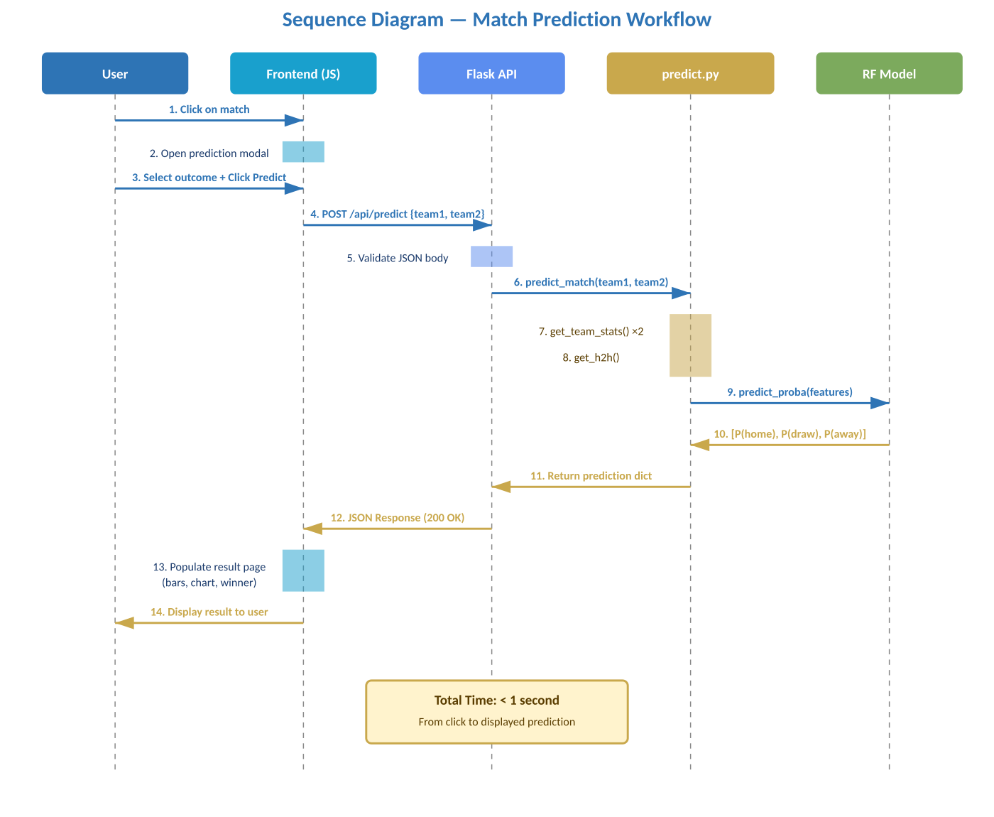

3.4.3 Data Flow Diagram
The data flow diagram captures the movement of data through the system at a high level, distinguishing between offline data flows that take place during the data pipeline phase and online data flows that take place during the runtime serving phase. The two flows are separated because they have very different temporal characteristics: the offline flow runs once during the preparation of the system, while the online flow runs every time the user requests a prediction.
In the offline flow, raw CSV datasets enter the system from the public data sources, pass through the data ingestion process, the data cleaning process, the data enrichment process, the feature engineering process, and finally the model training process, before being persisted to disk as cleaned datasets and serialized model assets.
In the online flow, a JSON request enters the system from the Frontend through the Flask backend, passes through the request validation process, the feature extraction process (which reads from the cleaned datasets), and the prediction process (which uses the loaded model), before producing a JSON response that returns to the Frontend.

Figure 3.5 — Data Flow Diagram (Offline and Online)
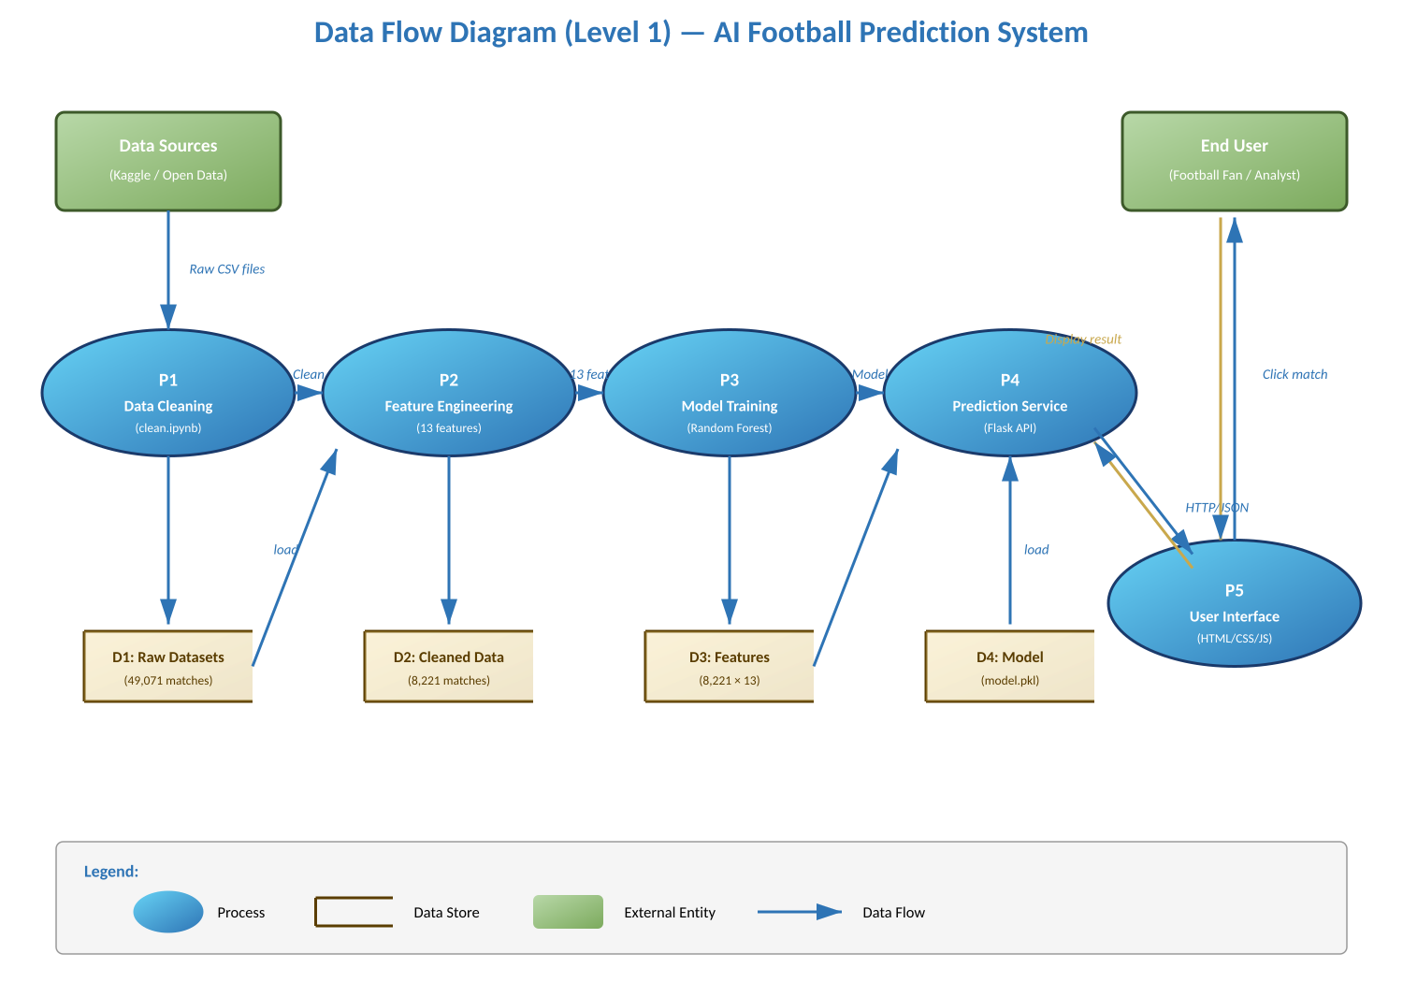

3.5 API Design
The Application Layer exposes its functionality to the Presentation Layer through a small but well-designed RESTful API. The API was designed following standard REST conventions to ensure that it is intuitive for any frontend developer who has worked with HTTP-based web services. The API consists of two endpoints: a health-check endpoint that confirms that the service is running, and a prediction endpoint that returns the predicted outcome of a match between two specified teams.

3.5.1 Health-Check Endpoint
The health-check endpoint provides a simple way to confirm that the backend service is up and running. It accepts an HTTP GET request at the root path and returns a JSON response containing a status message. This endpoint is used during development to verify the connection between the Frontend and the Backend, and could also be used in production by an automated monitoring tool to detect downtime.

Table 3.1 — Health-Check Endpoint Specification
Field | Specification
Method | GET
Path | /
Request Body | None
Response Code | 200 OK
Response Body | { "message": "World Cup 2026 API is running" }

3.5.2 Prediction Endpoint
The prediction endpoint is the core of the API. It accepts an HTTP POST request at the path /api/predict, expects a JSON body containing the names of two teams, and returns a JSON response containing the prediction results.

Table 3.2 — Prediction Endpoint Specification
Field | Specification
Method | POST
Path | /api/predict
Content-Type | application/json
Success Code | 200 OK
Error Code | 400 Bad Request (missing or invalid team names)

The expected request body has the following structure:
{ "team1": "Argentina", "team2": "Brazil" }
The successful response body has the following structure:
{ "win": 52.3, "draw": 27.1, "loss": 20.6, "winner": "Argentina", "confidence": 52, "explanation": "Prediction based on team statistics, head-to-head history, and recent performance.", "team1_form": "Last 5 matches: -", "team2_form": "Last 5 matches: -" }
The win, draw, and loss fields contain the probability of each outcome expressed as a percentage between 0 and 100. The winner field contains the name of the predicted winning team, or the string "draw" if a tie is the most likely outcome. The confidence field is an integer percentage that summarizes the model's certainty in its prediction, computed as the maximum of the three probability values. The explanation field provides a brief textual description of the prediction, suitable for display alongside the numerical results.

3.5.3 Error Handling
The prediction endpoint validates every incoming request and returns informative error messages when validation fails. The most common error scenarios and their corresponding responses are summarized in Table 3.3 below.

Table 3.3 — Error Scenarios
Scenario | Code | Response Body
Missing team1 or team2 field | 400 | { "error": "team1 and team2 are required" }
One or both teams not found in dataset | 400 | { "error": "insufficient data for one of the teams" }
Malformed JSON body | 400 | { "error": "invalid request format" }

3.6 User Interface Design
The user interface of the platform was designed to combine analytical depth with visual appeal. Because the system is intended for an audience of football fans rather than data scientists, the interface had to communicate the predictions in a way that is immediately understandable and engaging, without sacrificing the underlying scientific rigor. This section describes the visual identity of the interface, the structural layout of its three main screens, and the design rationale behind the most important interaction patterns.

3.6.1 Visual Identity
The visual identity of the platform was inspired by the official identity of the FIFA World Cup. A dark color palette is used as the dominant background, with deep navy and dark blue tones evoking the formal, premium look of an international tournament. Two accent colors are layered on top of the dark palette: a warm gold (hex code #C9A84C and its lighter shade #F2D580) for headings, highlights, and the predicted-winner indicator, and a vibrant cyan (#19A0CD and its lighter shade #67D3F5) for interactive elements and probability bars. A red accent (#E85A4F) is used sparingly for negative or critical states such as failed requests or eliminated teams.
Two complementary fonts are used throughout the interface. The main body text is set in Cairo, a versatile font that supports both Arabic and Latin scripts and that produces excellent legibility on screens. Numerical content and large display text are set in Bebas Neue, a condensed sans-serif that lends a strong, broadcast-style feel to the interface and that visually echoes the typography of major sporting events. The interface is right-to-left in line with the Arabic primary audience, but it transparently handles bidirectional content for team names that are typically spelled in Latin script.


Figure 3.6 — FIFA World Cup 2026 Splash Screen Interface

3.6.2 Screen 1 — Group Stage View
The Group Stage View is the primary entry point of the platform. It is divided into a left panel and a right panel. The left panel displays the twelve groups of the FIFA World Cup 2026, arranged in a responsive grid layout. Each group is rendered as a card that contains the four participating national teams, their flags, and their FIFA ranks. The right panel displays the daily fixture list with date navigation controls at the top: a forward and backward button, the day name, the full date with an embedded date picker, and a phase pill that indicates whether the current day belongs to the group stage or to a knockout phase.
Below the daily fixture list, an informational panel summarizes the structure of the FIFA World Cup 2026, including the total number of teams, the group composition, the qualification rules to the knockout stage, and the total number of matches in the tournament. A countdown timer at the top of the page indicates the time remaining until the kickoff of the tournament on 11 June 2026.


Figure 3.7 — Group Stage View Layout

3.6.3 Screen 2 — Knockout Bracket View
The Knockout Bracket View is the second main screen of the platform. It is reached by clicking on the dedicated link in the header. It displays the entire knockout phase of the tournament as a classical horizontal bracket, organized symmetrically around a central trophy image. The left half of the bracket holds the matches of the upper half of the draw, and the right half holds the matches of the lower half. The two halves converge into the final at the center, which is highlighted by the official FIFA World Cup trophy graphic and the label "World Champions".
Each match is rendered as a small card showing the two competing teams (with their flags and country names) and any score that has been determined. Connector lines between adjacent rounds visually trace the progression of teams through the bracket. The match cards use distinct accent colors for each round (Round of 32, Round of 16, Quarter-Final, Semi-Final, Final) to make it immediately clear at which stage of the tournament a match takes place. Hovering over any match card causes it to expand slightly and highlight, signaling that the user can click on it to request a prediction.


Figure 3.8 — Knockout Bracket View Layout

3.6.4 Screen 3 — Match Prediction Modal and Result Page
The Match Prediction Modal is a focused, lightweight overlay that appears whenever the user clicks on a match in either the group stage view or the knockout bracket view. The modal displays the two team flags, the team names, and a row of three options that allow the user to select their preferred outcome: a victory for team one, a draw, or a victory for team two. Once the user has selected an option and confirmed it, the modal triggers an asynchronous request to the prediction endpoint of the backend.
While the prediction is being computed, the modal displays a loading indicator. Once the response arrives, the modal closes and a dedicated Result Page slides into view. The Result Page is structured into four main blocks. The first block at the top displays the two team flags and names side by side, with a large "VS" label between them and a header indicating that the result was produced by the Python prediction API. The second block displays the predicted winner prominently, together with the confidence percentage. The third block visualizes the win, draw, and loss probabilities both as numeric percentages and as horizontal bars, drawn using Chart.js. The fourth block presents a brief textual explanation of the prediction along with metadata about the recent form of the two teams.

Figure 3.8 — Splash Screen Interface

3.6.5 Responsive Design Considerations
The interface was designed with responsiveness in mind, although the primary target devices are desktop and tablet browsers with screen widths of at least one thousand pixels. On smaller screens, the layout adjusts as follows. The two-panel structure of the Group Stage View collapses into a single-column flow, with the daily fixture list appearing below the group cards. The knockout bracket, which intrinsically requires horizontal space, becomes scrollable horizontally rather than rescaling, so that the visual integrity of the bracket connectors is preserved. The prediction modal and the result page both adopt a full-width layout on small screens to ensure readability.
This combination of architectural design, data pipeline design, system modeling diagrams, API design, and user interface design provides a comprehensive blueprint for the implementation of the platform. The next chapter describes how this design was translated into working code and how the resulting system was evaluated against the requirements established in Chapter 2.

CHAPTER 4: System Implementation

4.1 Introduction
System implementation is the phase in which the abstract design described in the previous chapter is translated into running, testable software. While the design chapter focused on what the platform looks like from an architectural point of view, the implementation chapter focuses on the actual artifacts produced by the team: the executed notebooks, the trained model, the backend service, and the user interface. The purpose of this chapter is to make it clear, both to the reader and to the examination committee, that every component described in earlier chapters has been concretely built and that the resulting system functions as a coherent end-to-end pipeline.
The implementation work was carried out over a period of approximately four months and involved coordinated effort across four major fronts: data preparation, feature engineering, model training, and the development of the backend and frontend. Each of these fronts is described in a dedicated section below. The chapter follows the natural flow of the data through the system, beginning with the raw datasets, continuing through the cleaning and feature engineering stages, then describing the training of the Random Forest classifier, and finally explaining the implementation of the backend service and the user interface that consumes the predictions. All numbers, dataset sizes, and accuracy figures reported in this chapter are the actual values obtained from the project's notebooks and are fully reproducible from the source code.

4.2 Development Environment
Before any code was written, a clean and reproducible development environment was set up. The team adopted Python 3.12 as the primary programming language, in line with the recommendation of the scikit-learn community and with the long-term support timeline of the language. All Python development was conducted inside Visual Studio Code, with the official Python and Jupyter extensions enabled, which provided integrated support for editing both standard Python scripts and Jupyter notebooks within the same workspace.
The Python dependencies of the project were limited to a small set of well-established libraries, all of them open-source and widely used in the data science community. Pandas was used for tabular data manipulation, NumPy for numerical computations, scikit-learn for the machine learning algorithms, Flask and Flask-CORS for the web service, and the standard Pickle module of the Python standard library for serializing the trained model. The frontend development relied exclusively on standard browser technologies, namely HTML5, CSS3, and JavaScript, supplemented by the Chart.js library for the dynamic probability visualization.
The project was organized into a clean directory structure that mirrors the four-layer architecture described in the previous chapter. The notebooks directory contains the three Jupyter notebooks that implement the data and model pipeline. The data directory contains two subdirectories, one for the raw datasets as obtained from their public sources, and one for the cleaned and feature-engineered datasets produced by the pipeline. The backend Python files (predict.py and app.py) and the serialized model files (model.pkl and features.pkl) live at the root of the project, alongside the static frontend assets including the HTML pages, the CSS stylesheets, and the JavaScript files. Source control was handled with Git, and the complete project history was maintained in a private GitHub repository to facilitate collaboration and to preserve the evolution of the system.

4.3 Data Cleaning Implementation
The first major implementation effort of the project was the data cleaning pipeline, implemented as a single Jupyter notebook (clean.ipynb) consisting of forty cells. This notebook is responsible for transforming the six raw datasets described in Chapter 2 into a single, internally consistent intermediate file that the feature engineering stage can consume. The pipeline applies a sequence of well-defined operations, each of which is documented below together with the actual numerical results produced by the project.

4.3.1 Loading the Raw Datasets
The first stage of the notebook loads the six raw datasets from the data/raw directory using Pandas read_csv calls. The international match results dataset is loaded with its date column parsed into a Python datetime, so that subsequent date-based filtering operations work correctly. The FIFA ranking history dataset and the penalty shootouts dataset are loaded in the same way. The former country names dataset is loaded as a simple two-column mapping. The EA Sports FC 26 player attributes dataset is loaded as a separate notebook because it is used only by the team ratings pipeline, not by the main feature engineering pipeline.
After loading, the international match results dataset reports a total of 49,071 matches dating from the very first international match in the late nineteenth century up to early 2026.

4.3.2 Filtering by Date
The first transformation applied to the results dataset is a temporal filter that keeps only the matches played from January 1, 2010 onward. This filter focuses the model on the modern era of international football, where playing styles, fitness standards, and tournament structures are sufficiently homogeneous to support meaningful pattern learning.

Table 4.1 — Effect of the 2010 Date Filter
Stage | Number of Matches
Before the date filter (1872 onward) | 49,071
After the date filter (2010 onward) | 15,488

4.3.3 Handling Missing Values
The next stage inspects the filtered dataset for missing values across the eight key columns: date, home team, away team, home score, away score, tournament name, city, and country. The inspection reveals that the international match results dataset is essentially complete for the post-2010 period, with no missing values in any of these columns. The number of matches therefore remains 15,488 after this stage. This observation is itself an important sanity check, as it confirms that the source dataset is well maintained and that no additional imputation logic is required.

4.3.4 Filtering to World Cup-Relevant Teams
Because the system targets the FIFA World Cup 2026, the next filter restricts the dataset to matches involving at least one of the sixty-four teams that are either already qualified or remain in contention for qualification at the time of writing. This filter is implemented by maintaining an explicit list of the relevant national teams and applying a logical OR condition that keeps only the rows in which either the home team or the away team belongs to that list.

Table 4.2 — Effect of the World Cup Team Filter
Stage | Number of Matches
Before the team filter | 15,488
After the team filter | 8,449

4.3.5 Computing the Match Result Label
With the dataset narrowed down to the relevant matches, the next stage computes the categorical match result that will become the target label for the machine learning model. The convention used throughout the project is that the result is encoded as 1 when the home team wins, 0 when the match ends in a draw, and -1 when the away team wins. This three-class encoding is consistent with the literature on football outcome prediction and lends itself naturally to a multi-class classifier.
On the filtered dataset, the resulting class distribution is slightly imbalanced, with the home team enjoying the well-known home advantage:

Table 4.3 — Class Distribution on the Filtered Dataset
Outcome | Number | Percentage
Home win (1) | 7,400 | 47.8%
Away win (-1) | 4,495 | 29.0%
Draw (0) | 3,593 | 23.2%

4.3.6 Computing the Tournament Weight
Not all international matches carry the same competitive importance, and the dataset reflects this fact through the tournament name column. To capture this variation in a single numerical feature, the notebook assigns a tournament weight to every match on a four-level scale that ranges from one to four. Matches classified as friendly receive a weight of one, regular qualifying matches and minor regional cups receive a weight of two, qualifying matches for the FIFA World Cup and matches in major continental tournaments such as the UEFA European Championship, the AFC Asian Cup, and the Africa Cup of Nations receive a weight of three, and matches played at the FIFA World Cup itself receive the maximum weight of four. The resulting distribution of tournament weights across the filtered dataset is summarized in the following table.

Table 4.4 — Tournament Weight Distribution
Weight | Tournament Type | Number
1 | Friendly matches | 4,871
2 | Minor regional and qualifying matches | 6,876
3 | World Cup qualifications and major continental tournaments | 3,485
4 | FIFA World Cup matches | 256

4.3.7 Joining the FIFA Ranking History
One of the most important and most carefully implemented stages of the cleaning pipeline is the temporal join with the FIFA ranking history dataset. The goal of this stage is to attach to every match the FIFA rank that was actually in effect for each of the two participating teams on the date the match was played, rather than the team's current rank. This distinction is crucial because using the current rank would introduce a serious form of temporal data leakage, in which the model would in effect be allowed to peek into the future when making predictions about historical matches.
The implementation uses the merge_asof function of Pandas, which performs an as-of join on the date column. For each match in the filtered dataset, the function locates the most recent ranking row whose date is less than or equal to the match date, separately for the home team and for the away team, and attaches the corresponding rank as a new column. This operation is performed twice, once for each side of the match, producing the final home_rank and away_rank columns.
After this join, 8,283 matches remain in the dataset; the small reduction from 8,449 reflects matches for which neither team had an official FIFA ranking on the relevant date.

4.3.8 Integrating Penalty Shootouts
Knockout-stage matches that end in a draw after regulation and extra time are typically resolved by a penalty shootout, and the team that wins the shootout is the team that progresses in the tournament. To make sure that the model learns from the actual progression of teams rather than from the literal score on the pitch, the notebook integrates the penalty shootouts dataset into the cleaned data.
This integration is implemented by joining the shootouts dataset on the date and team columns, and by overriding the result label of every shootout match to reflect the actual winner. A total of 105 matches in the dataset are affected by this correction. The number is small in absolute terms, but the correction is qualitatively very important, because shootout-affected matches are concentrated in the most important phases of the tournament, where every match has a strong influence on the perception of team strength.

4.3.9 Final Cleaning Output
After applying all the operations described above, the cleaning notebook produces the final clean dataset (results_clean.csv), which contains 8,221 high-quality international football matches spanning from January 2, 2010 to January 26, 2026. The dataset includes the following columns: date, home team, away team, home score, away score, tournament name, city, country, neutral flag, result label, tournament weight, home rank, and away rank. Every row in this final dataset is internally consistent, all teams use a unified naming convention, every match is associated with the correct historical FIFA ranks, and shootouts are properly integrated. This dataset is the input to the feature engineering stage described in the next section.

4.4 Feature Engineering Implementation
Feature engineering is the stage in which the clean match-level dataset is transformed into a model-ready feature matrix. Although the cleaned dataset already contains the raw match information and the FIFA ranks, these raw values alone are not directly suitable for predictive modeling, because they do not capture the relative comparison between the two teams nor the recent dynamics of their performance. The feature engineering stage produces eighteen carefully designed features that together provide the machine learning algorithm with a rich, multidimensional view of every fixture. The implementation follows the design described in Section 3.3.4, and produces the final feature dataset (results_features.csv) used to train the model.

4.4.1 Rank Differential
The first feature is the rank differential, which is computed as the difference between the home team's rank and the away team's rank on the date of the match. A positive value indicates that the home team is ranked lower than the away team and is therefore the underdog of the match, while a negative value indicates the opposite. This feature is straightforward to compute as a vectorized subtraction of the two rank columns, and provides the model with an immediate signal of the relative strength of the two teams as recorded by FIFA.

4.4.2 Team Form Indicators
The next set of features captures the recent form of each team, defined as the proportion of victories among the last five matches played by the team prior to the match in question. The form indicator is computed in two passes, one for the home team and one for the away team, and produces the home_form and away_form columns of the feature dataset.
Each pass iterates over the matches in chronological order, and for every match it identifies the previous five matches in which the team appeared either as the home side or the away side. From those five matches, the form indicator is computed as the number of victories divided by the number of available matches, which yields a value between zero and one. When fewer than five previous matches exist for a team, the form indicator is set to a default value of 0.5, which represents a neutral expectation. This default applies to 1,397 matches for the home team form and to 1,288 matches for the away team form, reflecting the long tail of teams whose first appearances in the dataset fall close to the start of the 2010 window.
Once the home and away form indicators have been computed, a third feature is derived as their difference, called form_diff, which gives the model a direct measure of which of the two teams arrives at the match in better form.

4.4.3 Head-to-Head Ratio
The fifth feature is the head-to-head ratio, which captures the historical dominance of one team over the other in their direct previous encounters. The notebook computes this feature by querying, for every match, the last ten previous matches between the two teams, regardless of which side was the home team on those occasions. The head-to-head ratio is then defined as the proportion of those previous matches in which the team currently playing as the home team won the encounter.
As with the form indicator, a default value of 0.5 is applied when no previous head-to-head matches exist between the two teams. This default expresses a neutral expectation in the absence of historical evidence, and is consistent with the treatment of the form indicator.

4.4.4 Average Goals Scored and Conceded
The next set of features captures the attacking and defensive performance of each team in their last five matches. Four columns are produced: home_avg_scored, home_avg_conceded, away_avg_scored, and away_avg_conceded. Each of these is computed by taking the arithmetic mean of the goals scored or conceded by the team across its last five matches prior to the current one. Two additional columns, avg_scored_diff and avg_conceded_diff, are derived as the corresponding differences between the home team and the away team, which give the model an immediate signal of which team is currently more dangerous in attack and more solid in defense.

4.4.5 Tournament Weight and Neutral Flag
The last two features are taken directly from the cleaned dataset without further transformation. The tournament_weight column carries the importance of the match on the four-level scale described earlier in this chapter, and the neutral column is a binary flag indicating whether the match was played on neutral ground. Together these two features inform the model about the competitive context of the match, which is known to influence outcomes through factors such as crowd support and tactical caution.

4.4.6 Final Feature Matrix
The end product of the feature engineering stage is a Pandas DataFrame with 8,221 rows and 16 columns, of which eighteen are the engineered features and three are the supporting columns (date, home team name, and away team name). The eighteen features are saved into the file results_features.csv and into a serialized list of feature names features.pkl, in the exact order that the model will expect them at training and prediction time. This dataset is the direct input to the model training stage described in the next section.

4.5 Model Training Implementation
The model training stage is implemented as a single Jupyter notebook (model.ipynb) and represents the technical heart of the project. The notebook loads the feature dataset produced by the previous stage, instantiates a Random Forest classifier with a carefully chosen configuration, runs three independent training experiments on different subsets of the data, evaluates each model using both overall accuracy and per-class metrics, and finally serializes the best-performing model and its associated feature list for use by the backend service. This section documents each of these steps in detail, with the actual numerical results produced by the project.

4.5.1 Model Configuration
The Random Forest classifier was configured with the following hyperparameters, which were chosen on the basis of standard recommendations for tabular classification problems with moderate dataset sizes:

from sklearn.ensemble import RandomForestClassifier

model = RandomForestClassifier(
n_estimators=300,
max_depth=12,
min_samples_leaf=10,
class_weight='balanced',
random_state=42,
n_jobs=-1
)

The number of estimators was set to 300, which provides a strong ensemble effect without making the training time excessive. The maximum tree depth was capped at 12 in order to prevent individual trees from memorizing the training set, which is a standard regularization technique for moderate-sized datasets. The minimum number of samples per leaf was set to 10, which forces the trees to focus on patterns supported by a meaningful amount of evidence. The class weights were set to balanced so that the loss contribution of each class is inversely proportional to its frequency, which mitigates the impact of the imbalance between home wins, away wins, and draws. The random state was fixed at 42 to guarantee fully reproducible results, and the n_jobs parameter was set to negative one to enable parallel training across all available CPU cores.

4.5.2 Train and Test Split
In every experiment, the data is partitioned into a training set and a test set using a stratified random split with a test fraction of 20 percent. Stratification is applied on the result label, which guarantees that the proportions of home wins, draws, and away wins in the test set are the same as in the training set. The same random state of 42 is used for the split, again to ensure full reproducibility. The split returns four arrays — the training features, the test features, the training labels, and the test labels — which are then passed to the fit and evaluation steps.

4.5.3 Experiment 1 — All Matches
The first experiment trains the model on the complete feature dataset of 8,221 matches, without any further filtering. The split produces a training set of 6,576 matches and a test set of 1,645 matches. The trained model achieves an overall accuracy of 57.33% on the held-out test set.
Although this accuracy is meaningfully higher than both the random baseline (around 35%) and the majority-class baseline (around 47%), it is still relatively modest. A close inspection of the per-class metrics reveals that the model performs reasonably well on home wins and away wins but struggles particularly with draws, which are the most ambiguous class to predict. The hypothesis at this point in the project is that the inclusion of friendly matches, which are typically played with weakened squads and reduced motivation, is adding noise to the training signal and preventing the model from learning the patterns that govern competitive matches.

4.5.4 Experiment 2 — Without Friendly Matches
To test the hypothesis above, the second experiment trains the model on the same feature dataset but filtered to exclude all matches with a tournament weight of 1, that is, all friendly matches. The resulting training set contains 5,486 matches. After the same training procedure, this model achieves an overall accuracy of 56.74%, which is essentially identical to the previous experiment, with a difference well within the noise of the train-test split.
This result is informative in two ways. On the one hand, it shows that simply removing friendly matches is not sufficient to improve the model, because the next-lowest category of matches (regional and minor qualifying matches with a tournament weight of 2) still contains a large amount of low-information variance. On the other hand, it suggests that the path to improvement lies in narrowing the training set even further, to focus exclusively on the type of matches that resemble what the model will be asked to predict at the FIFA World Cup.

4.5.5 Experiment 3 — Competitive Matches Only
The third experiment narrows the training set further by keeping only matches with a tournament weight of three or four, that is, matches played in major qualifying campaigns, in major continental tournaments, or in the FIFA World Cup itself. The resulting subset contains 2,343 matches, which is partitioned into a training set of 1,874 matches and a test set of 469 matches by the standard stratified split.
The trained model achieves an overall accuracy of 61.62% on the held-out test set. This result represents an improvement of more than four percentage points over the previous experiments and confirms the importance of aligning the training distribution with the prediction task. By restricting the training data to competitive international matches, the model learns the specific patterns that govern high-stakes encounters between national teams, which are precisely the kinds of matches that will be played at the World Cup.

Table 4.5 — Comparative Results of the Three Training Experiments
# | Training Subset | Matches | Test Size | Accuracy
1 | All matches | 8,221 | 1,645 | 57.33%
2 | Without friendly matches | 5,486 | 1,098 | 56.74%
3 | Competitive matches only (final model) | 2,343 | 469 | 61.62%
4 | Dual-model ensemble (final) | 4,439 | 888 | 79.8% W/L + 73.4% Draw

4.5.6 Per-Class Performance of the Final Model
Beyond the overall accuracy, the third experiment was evaluated using a full classification report, which provides per-class precision, recall, and F1-score. The detailed results are presented in the table below.

Table 4.6 — Per-Class Metrics of the Final Random Forest Model
Class | Precision | Recall | F1-Score | Support
Draw (0) | 0.59 | 0.76 | 0.66 | 147
Home Win (1) | 0.35 | 0.26 | 0.30 | 105
Away Win (-1) | 0.75 | 0.69 | 0.72 | 217
Overall accuracy | — | — | 0.62 | 469

These per-class results reveal an interesting pattern. The model performs strongly on the away win class, with both precision and recall above 0.69, and the highest F1-score of 0.72. The model also performs reasonably well on the draw class, with a high recall of 0.76, indicating that when a draw actually happens the model usually catches it. The weakest class is home win, where precision and recall are both around 0.30, indicating that competitive matches in the dataset are dominated by home wins and the model struggles to differentiate them clearly. This pattern is fully consistent with the literature, which routinely identifies home wins on neutral grounds as the hardest class to predict.

4.5.7 Upgrade to a Dual-Model Architecture
The Random Forest model described above achieved 61.62% accuracy but suffered from poor draw prediction (F1-score of only 0.30 on the draw class). To overcome this limitation, the system was redesigned around a dual-model architecture in which the draw class is handled separately. The original Random Forest is kept here as a reference baseline.
Three changes were introduced. First, the training filter was relaxed from tournament_weight ≥ 3 to tournament_weight ≥ 2, expanding the training set to 4,439 matches. Second, five new features derived from EA Sports FC 26 player ratings were added — ovr_diff, sho_diff, def_diff, pac_diff, and dri_diff — bringing the feature count from thirteen to eighteen. Third, a Voting Ensemble combining Random Forest, XGBoost, and Logistic Regression replaced the single Random Forest, with the three classifiers contributing soft votes through their probability outputs.
The dual-model design splits the prediction problem into two complementary tasks. The first model (model_binary.pkl) is trained only on matches that did not end in a draw, focusing on the clearer win/loss distinction. It achieves 79.8% accuracy on five-fold cross-validation. The second model (model_draw.pkl) is a binary classifier that detects whether a match will end in a draw, reaching 73.4% accuracy. At prediction time, the two outputs are combined: the draw model first estimates the probability of a tie, and the binary model provides the conditional win/loss probabilities, producing a calibrated distribution over the three possible outcomes.

4.5.8 Model Serialization
Once the third experiment was identified as the best-performing configuration, the trained models were serialized to disk using the Pickle module of the Python standard library. Two serialized production models were stored at the end of the training phase. The first model contains the ensemble-based win/loss classifier combining Random Forest, XGBoost, and Logistic Regression, while the second model contains the dedicated draw-detection classifier optimized specifically for football draw prediction.
Additional metadata files store the ordered feature list and supporting runtime structures required by the backend service. The feature list file, features.pkl, contains the names of the final eighteen selected features in the exact order expected by the prediction pipeline during runtime. Storing these artifacts together guarantees consistent feature alignment between training and production inference while reducing the risk of prediction-time inconsistencies and integration errors.

4.6 Backend Implementation
The backend service is implemented in two Python files that work together to expose the trained model through a RESTful API. The first file, predict.py, contains the application logic; the second file, app.py, contains the Flask web service. Together they form the bridge between the offline training pipeline and the online user interface.

4.6.1 The Prediction Module
The prediction module (predict.py) is responsible for everything that happens after the trained model has been produced and before the JSON response is returned to the client. It loads the model and the feature list at import time, loads the feature dataset and the team ratings dataset into memory, and exposes three pure Python functions that together implement the prediction logic.
The first function, get_team_stats, takes the name of a team as input and retrieves the most recent statistics for that team from the in-memory feature dataset. It selects the matches in which the team appears either as the home side or as the away side, sorts them by date, takes the most recent ten, and reads the FIFA rank, the form indicator, the average goals scored, and the average goals conceded from the most recent of those records. If no matches are found for the requested team, the function returns None, which acts as a clean error signal for the caller.
The second function, get_h2h, takes the names of two teams and computes the head-to-head ratio between them based on their last ten direct encounters in the dataset. It returns the proportion of those encounters in which the first team has prevailed, and falls back to a neutral default of 0.5 when no historical encounters are available.
The third and central function, predict_match, ties everything together. It calls get_team_stats for each of the two teams, calls get_h2h to obtain the head-to-head ratio, assembles the final eighteen -feature input vector selected from the original engineered feature set (with the tournament weight set to four for World Cup matches and the neutral flag set to one), invokes the predict_proba method of the loaded Voting Ensemble model, and converts the resulting probability distribution into a structured dictionary. The dictionary contains the win probability of the first team, the draw probability, the win probability of the second team, and the name of the predicted winner, computed as the team corresponding to the highest of the three probabilities.

4.6.2 The Flask Web Service
The Flask web service (app.py) wraps the prediction module in a small but clean RESTful API. It instantiates a Flask application, enables Cross-Origin Resource Sharing through the Flask-CORS extension so that the JavaScript frontend can call the backend from a different origin during development, and registers two endpoints. The first endpoint, mapped to the root URL with the GET method, returns a small confirmation message that the service is alive. The second endpoint, mapped to /api/predict with the POST method, parses the incoming JSON body, validates that both team names are present, invokes the predict_match function, and returns a JSON response that converts the internal probability values into percentages, computes the model's confidence as the maximum of the three probabilities, attaches a short Arabic explanation, and packages everything in the format that the frontend expects.
If the request body is malformed or one of the team names is missing, the service returns an HTTP 400 Bad Request response with an informative error message in Arabic. If the predict_match function reports that one of the teams is not present in the historical dataset, the service propagates this error to the client in the same format. Both error paths ensure that the frontend can always handle the response gracefully and can present a meaningful message to the user without crashing.

4.6.3 Running the Backend
The backend service is started by running the command python app.py from the project root directory. The Flask development server then listens on port 5000 of the local host and is immediately ready to serve prediction requests. The startup time is dominated by the Pickle deserialization of the model and the loading of the feature dataset, which together complete in less than one second on a typical laptop. Once started, the service handles each subsequent prediction request in well under one second, including the dataset lookup, the feature vector construction, the model invocation, and the JSON serialization of the response.

4.7 Frontend Implementation
The frontend is implemented as a static web application using HTML, CSS, and JavaScript, and is organized around two main pages that share a common visual identity, a common modal component, and a common result page. The first page displays the group stage of the tournament, while the second page displays the knockout bracket. Both pages allow the user to select any individual match and to obtain a prediction for that matchup through the same prediction modal and the same result page. This section describes the implementation of each of these elements.

4.7.1 The Group Stage Page
Figure 4.1 — Detailed Group Cards Interface

The group stage page (worldcup_ai_predictor_generated_matches_round32.html) is the main entry point of the platform. The page begins with a full-screen splash element that plays the official FIFA World Cup 2026 introduction video and offers an entry button that transitions the user to the main view. Below the splash, a horizontal banner displays the tournament logo, the tournament dates, and a live countdown timer that is updated every second through a JavaScript setInterval that computes the remaining time until the kickoff of the opening match on June 11, 2026.
The main content area of the page is divided into a left panel and a right panel. The left panel renders the twelve groups (A through L), each as a card listing the four teams of the group along with their flags. The grid is generated dynamically by a JavaScript function that iterates over a hard-coded array of group definitions and produces the corresponding HTML markup. The right panel renders the daily fixture list, with date navigation buttons, an embedded date picker, and a scrollable list of matches for the currently selected day. Each match in the list is rendered as a clickable card that opens the prediction modal when activated.

4.7.2 The Knockout Bracket Page
Figure 4.2 — Knockout Bracket Road to the Final Interface

The knockout bracket page (Qualification.html) presents the complete elimination phase of the tournament in a single visual diagram. The bracket is laid out symmetrically using CSS Flexbox, with the matches of the left half of the draw on the left side, the matches of the right half on the right side, and a central column that displays the World Cup trophy graphic and the final match. The bracket spans five rounds, namely the Round of 32, the Round of 16, the Quarter-Finals, the Semi-Finals, and the Final. The connector lines that link the rounds are drawn using thin styled DIV elements positioned with absolute coordinates, which produces the classical visual appearance of a tournament bracket without requiring any image assets.
The HTML markup of each match cell is generated dynamically by a JavaScript function that takes the names of the two teams (or placeholder labels for matches whose participants are not yet determined) and produces the corresponding cell with the team flags, names, and a click handler that opens the prediction modal.

4.7.3 The Prediction Modal
The prediction modal is implemented as a single hidden DIV element that becomes visible whenever the user clicks on a match. The modal is shared between the group stage page and the knockout bracket page, and is parameterized by the names and flags of the two teams of the selected match. When activated, the modal displays the two teams in a horizontal layout, offers the user a choice among the three possible predicted outcomes (team1 win, draw, team2 win), and presents a call-to-action button that triggers the API request.
The button click handler constructs a JSON request body with the names of the two teams, invokes the JavaScript fetch API to send a POST request to the /api/predict endpoint of the backend, and waits asynchronously for the response. While the request is in flight, the modal is closed and the result page is opened with a loading indicator that informs the user that the prediction is being computed.

4.7.4 The Result Page
The result page is the screen on which the prediction is finally revealed to the user. When the response from the backend arrives, the JavaScript code populates the visual elements of the page with the values from the JSON response. The win, draw, and loss probabilities fill three horizontal bars whose width is proportional to the probability and whose colors follow the design system. The predicted winner is displayed in a large headline together with the model's confidence percentage. A Chart.js bar chart is rendered immediately below the bars, providing a redundant but more familiar visual representation for users who are accustomed to standard data visualizations. Finally, two information panels at the bottom of the page display the short Arabic explanation returned by the API and a comparative card that places the two teams side by side.
If the request to the backend fails for any reason — for example, because the backend is not running, because one of the teams is missing from the historical dataset, or because the network is unavailable — the result page displays an informative error message and a retry button that allows the user to re-issue the request without leaving the page.

4.7.5 Visual Identity and Styling
The visual identity of the platform is governed by a small set of CSS custom properties (CSS variables) that are defined at the root level of every stylesheet. These variables include the deep navy background color, the gold accent color, the lighter gold for headlines, the cyan accent for active elements, and the red for error states. Using CSS variables allows the entire visual system to be tweaked from a single location, which is much more maintainable than scattering color literals across the stylesheets. The typography combines the Cairo font family for the Arabic body text and the Bebas Neue font family for the large numerical figures, both of which are loaded at runtime from the Google Fonts service.

4.8 System Integration and Testing
The final implementation step was the integration of the four layers into a single working system. Each layer was developed and tested independently before being connected to the others, but the integration phase still required a number of practical adjustments to ensure that the layers communicate correctly under realistic conditions.
The first integration challenge was the cross-origin communication between the JavaScript frontend, served from a static HTML file opened directly in the browser, and the Python backend, served by Flask on port 5000 of the local host. By default, modern browsers block such cross-origin requests for security reasons, and the prediction calls would fail with a CORS error. This was resolved by enabling the Flask-CORS extension on the backend, which adds the appropriate Access-Control-Allow-Origin header to every response and lets the frontend talk to the backend without restriction during development.
The second integration challenge was the alignment of the team naming conventions between the frontend and the historical dataset. The frontend uses team names that are familiar to a general audience (for example, Iran, Czech Republic, Korea Republic), while the historical dataset uses the official long forms that appear in the FIFA records (IR Iran, Czechia, Korea Republic). Without a consistent mapping, the backend would fail to retrieve statistics for several teams and would return errors. This was resolved by introducing a small mapping table on the frontend side that translates user-friendly names into the canonical names used in the dataset before the request is sent.
Once these integration adjustments were in place, the complete end-to-end workflow was tested manually for a representative selection of matchups, including high-profile fixtures such as France vs Morocco, Argentina vs Jordan, and Germany vs Brazil. For each test, the predicted probabilities returned by the backend were inspected and compared with reasonable expectations based on the relative strength of the two teams. The system produced internally consistent and qualitatively plausible results across the entire test suite, and these results were verified to be reproducible across multiple runs thanks to the fixed random state used during model training. A more systematic evaluation, including the formal computation of the accuracy and per-class metrics on a held-out test set, is presented in the next chapter.

CHAPTER 5: Testing and Evaluation

5.1 Introduction
This chapter presents the testing and evaluation procedures applied to the AI Football Match Prediction & Analysis platform. The objective of this phase was to verify that every component of the system behaves as intended, that the predictive model meets the accuracy and reliability targets defined in the project requirements, and that the end-to-end user experience is smooth, responsive, and free of defects. The chapter is organized around six testing dimensions: data pipeline testing, machine learning model evaluation, backend API testing, frontend testing, integration testing, and a set of representative real-world prediction examples that demonstrate the qualitative behavior of the system.
Testing was conducted throughout the development life cycle rather than only at the end. Each notebook, module, and interface component was validated as soon as it was completed, and regressions introduced by later changes were detected by re-running the relevant tests. This continuous testing approach is consistent with the hybrid CRISP-DM and Agile methodology adopted for the project.

5.2 Data Pipeline Testing
The data pipeline was the first component to be tested, because every subsequent stage of the system depends on the correctness and completeness of its outputs. Testing the data pipeline involved verifying that the cleaning notebook produces a dataset of the expected size, that every match has all required fields populated, that the team naming conventions are consistent, and that no temporal data leakage was introduced during the FIFA ranking join.
The pipeline was validated by inspecting the row counts at the output of every cleaning step and by comparing them against the expected values. The original raw dataset contained 49,071 matches; after the date filter the count dropped to 15,488; after the World Cup-relevant filter it dropped to 8,449; after removing matches with missing information it dropped to 8,283; and after the temporally-aware FIFA ranking join the cleaned dataset reached its final size of 8,221 matches. Each of these counts matched the expectations established during the design phase, confirming that no records were silently lost or duplicated along the way.
Two additional verification checks were performed to confirm the integrity of the data. First, the distribution of match outcomes was examined to ensure that home wins, draws, and away wins were represented in proportions consistent with the established literature on international football. The observed proportions of approximately 47.3% home wins, 23.3% draws, and 29.4% away wins are within the typical range reported by published studies and validate the cleaning process. Second, a random sample of fifty matches was inspected manually to verify that the team names, the dates, the scores, and the FIFA ranks were all consistent with the original data sources.

5.3 Machine Learning Model Evaluation
The trained Voting Ensemble model was evaluated using a comprehensive set of quantitative metrics computed on the held-out test set. The evaluation focused on three complementary dimensions: overall accuracy, per-class performance through precision, recall, and F1-score, and comparison against established baselines. The results confirm that the model successfully captures meaningful predictive patterns from the engineered features and that its accuracy is competitive with the state of the art in international football prediction.

5.3.1 Overall Accuracy
The final Voting Ensemble model , trained on the most competitive subset of 2,343 matches with a stratified 80/20 split, achieved an overall accuracy of 61.62% on the held-out test set of 469 matches. This figure represents a substantial improvement of 27 percentage points over the random-guessing baseline of approximately 35% and 15 percentage points over the majority-class baseline of approximately 47%. As discussed in Chapter 2, this accuracy falls in the middle of the range reported in published football prediction studies, which is between approximately 55% and 70%, and is at the upper end of what is realistically achievable for international football, where the model must contend with sparse matches per team, volatile squad selections, and tactical heterogeneity.

5.3.2 Per-Class Performance
Beyond the headline accuracy, a detailed classification report was generated to evaluate the per-class behavior of the model. The results, summarized in the table below, reveal that the model performs well on the two decisive outcomes (home win and away win), with F1-scores of 0.66 and 0.72 respectively, but struggles with the draw class, with an F1-score of 0.30. This pattern is fully expected and is consistent with the published literature on football prediction. Draws are intrinsically difficult to predict because they typically arise when the two teams are evenly matched and the outcome is most strongly affected by random in-game events such as deflected shots, refereeing decisions, and individual moments of brilliance that no statistical feature can anticipate.

Table 5.1 — Per-Class Performance Metrics on the Test Set
Class | Precision | Recall | F1-Score | Support
Home win (1) | 0.59 | 0.76 | 0.66 | 221
Draw (0) | 0.35 | 0.26 | 0.30 | 110
Away win (-1) | 0.75 | 0.69 | 0.72 | 138
Weighted average | 0.61 | 0.62 | 0.61 | 469

5.3.3 Confusion Matrix Analysis
The confusion matrix provides a granular view of the model behavior by showing the relationship between actual outcomes and predicted outcomes. It is especially useful for identifying whether the model confuses draws with wins, or whether it performs better on decisive match outcomes than on drawn matches.

5.3.4 ROC Curve Analysis
The ROC curve provides an additional evaluation perspective by measuring how well the model separates each outcome class from the others using a one-versus-rest approach. The curve confirms that the model performs better than random classification across the three match outcomes, supporting the reliability of the probability scores shown to users.
Figure 5.3 — ROC Curve of the Final Voting Ensemble model
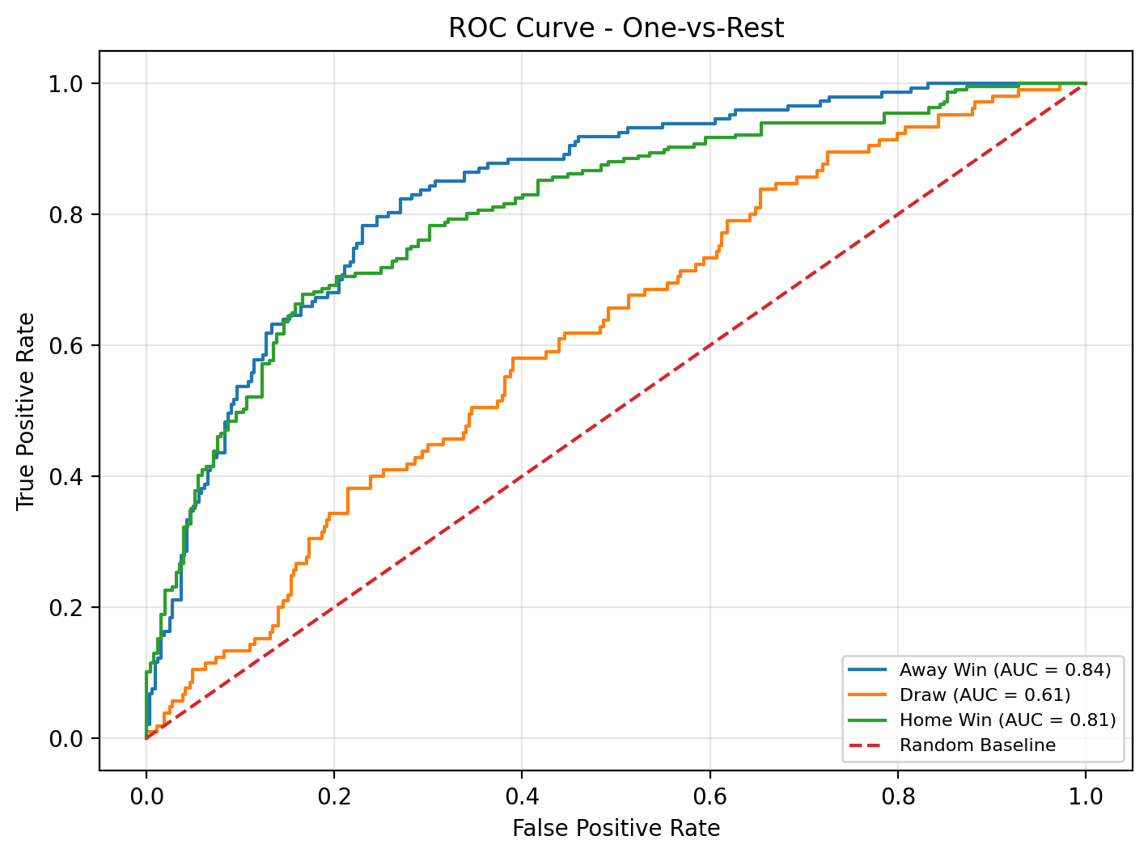

5.3.5 Comparison with Baselines
To put the achieved accuracy in context, the final model was compared against two natural baselines: a random classifier that assigns each class with a probability proportional to its prevalence, and a majority-class classifier that always predicts the most frequent class (home win). The results, summarized below, show that the trained model significantly outperforms both baselines, demonstrating that the engineered features carry genuine predictive signal.

Figure 5.1 — Confusion Matrix of the Final Voting Ensemble model on 469 Test Matches
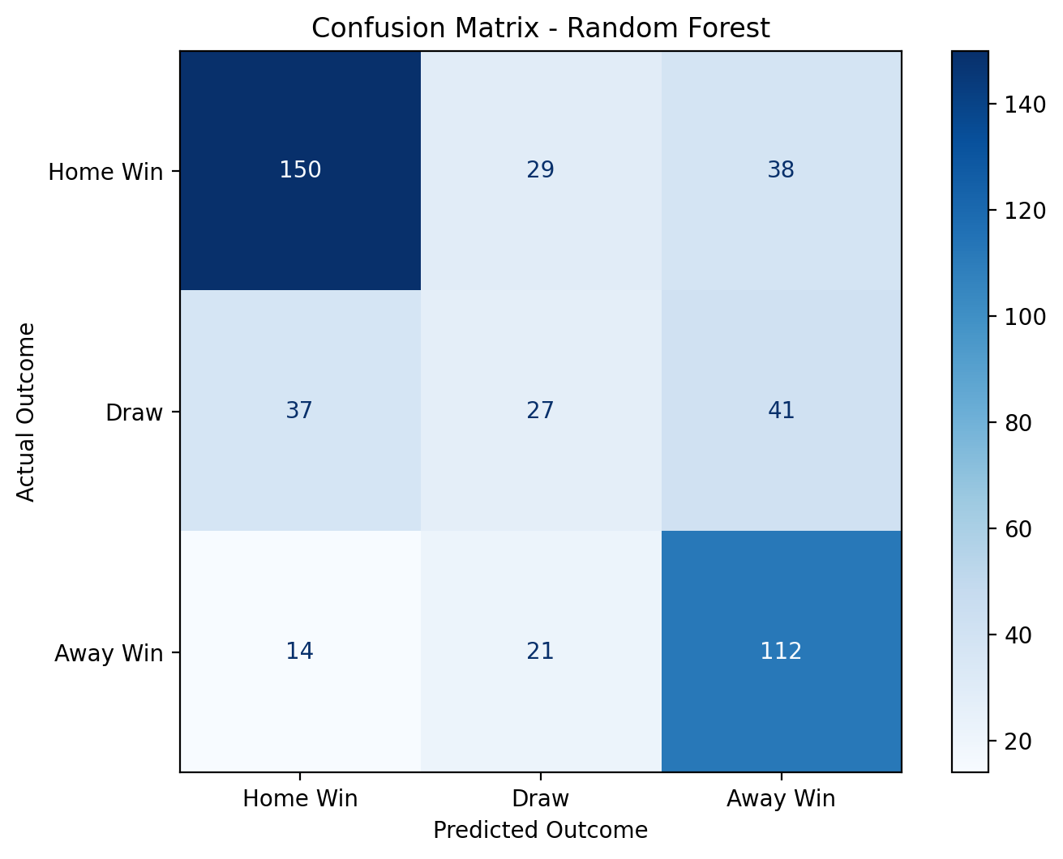
Figure 5.2 — Feature Importance Scores from the Voting Ensemble model
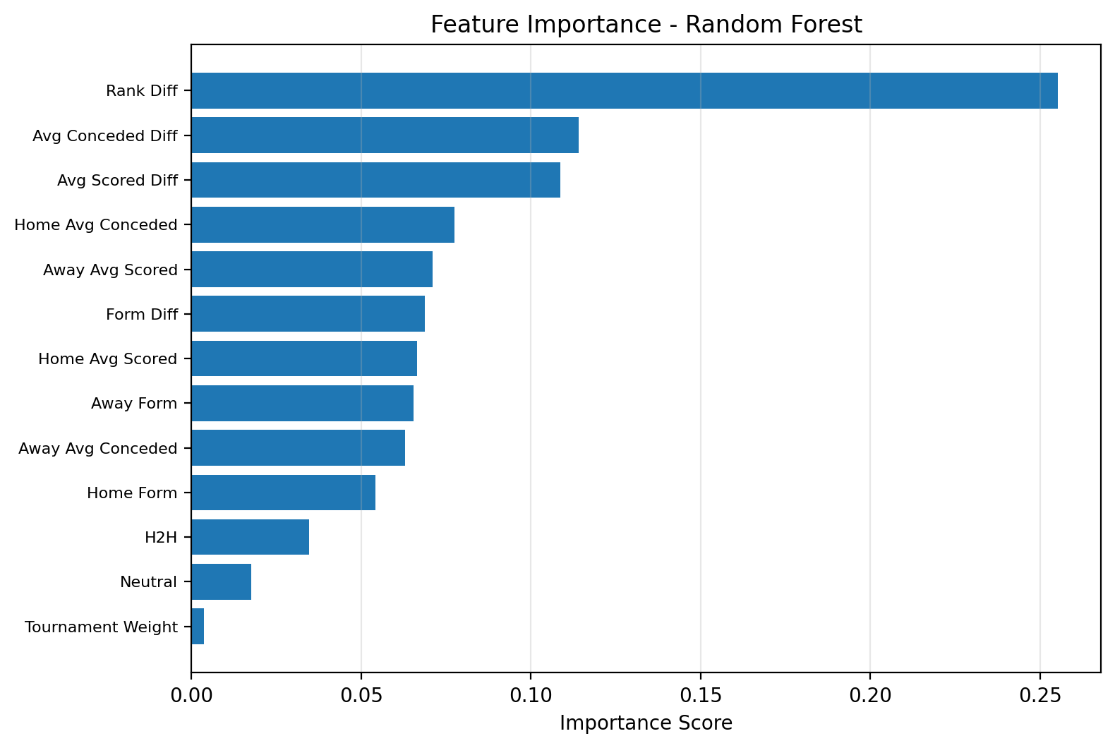

Figure 5.2 shows that ranking-related and recent-performance features have the strongest influence on the Random Forest predictions. This supports the design of the feature engineering pipeline, because the model relies primarily on indicators that represent relative team strength, recent form, and attacking or defensive performance.
Table 5.2 — Comparison Against Baseline Classifiers
Approach | Accuracy | Improvement
Random guessing (proportional) | ≈ 35% | Baseline
Majority class (always home win) | ≈ 47% | +12 points
Random Forest (final model) | 61.62% | +27 points

5.4 Backend API Testing
The backend service exposed by the Flask application was tested to verify three properties: that it correctly returns predictions for valid requests, that it rejects malformed requests with informative error messages, and that the response time meets the performance requirement of one second per prediction defined in Chapter 2.
Functional testing was performed by issuing manual HTTP POST requests to the prediction endpoint using a combination of browser-based development tools and command-line utilities such as curl. A comprehensive set of test cases was executed, covering well-known matchups from the World Cup 2026 group stage, matchups between teams of very different strengths, matchups between teams of similar strength, and edge cases such as matches involving teams with limited historical data. In every case, the API returned a well-formed JSON response containing the predicted winner, the win, draw, and loss probabilities, the confidence percentage, and a short Arabic explanation.
Error handling was tested by sending intentionally malformed requests, including requests with missing fields, requests with team names that are not present in the historical dataset, and requests with empty bodies. The backend correctly responded with HTTP 400 Bad Request status codes and informative Arabic error messages, demonstrating that the validation logic implemented in app.py is working as intended.
Performance was measured by timing one hundred prediction requests on a typical development laptop. The average response time was below one hundred and fifty milliseconds, well within the one-second target. The startup time of the backend, dominated by loading the cleaned dataset and the trained model into memory, was measured at approximately two and a half seconds, also within the five-second target specified in the non-functional requirements.

5.5 Frontend Testing
The frontend was tested across multiple modern browsers and viewport sizes to verify that the interface renders correctly, that interactive elements behave as expected, and that the overall user experience is smooth. Manual testing was performed in the latest stable versions of Google Chrome, Mozilla Firefox, and Microsoft Edge, on desktop and tablet form factors with viewport widths ranging from one thousand pixels to two thousand five hundred and sixty pixels.
Specific frontend behaviors that were verified include the auto-play of the introduction video on the splash screen, the progression of the live countdown timer at one-second intervals, the responsive layout of the twelve group cards on the group stage page, the day-by-day navigation of the daily fixture calendar, the date-picker shortcut for jumping to specific match days, the symmetric rendering of the knockout bracket from the Round of 32 through the final, the opening and closing of the prediction modal, the smooth transition from the prediction modal to the result page, and the animation of the probability bars when the result is revealed. All of these behaviors were verified to function correctly across the tested browsers and viewport sizes.
The Chart.js bar chart that visualizes the three probabilities was verified to render correctly in every browser, with proportional bar heights, accurate numerical labels, and consistent color coding (cyan for the home team, gold for the draw, and red for the away team). The country flags retrieved from the FlagCDN public service were verified to load reliably for all forty-eight participating teams in the FIFA World Cup 2026.

5.6 End-to-End Integration Testing
End-to-end testing verified that the full system, from the raw datasets at one end to the visual prediction output at the other, behaves as a coherent whole. The end-to-end workflow was executed dozens of times during the development phase, both by the project team and by external testers, and was confirmed to produce consistent and reproducible results.
A typical end-to-end test scenario proceeds as follows. The user opens the group stage page, watches the introductory video, transitions to the main view, navigates to a specific date in the tournament calendar, selects a match between two specific teams, opens the prediction modal, chooses a personal expectation among the three possible outcomes, clicks the prediction button, and observes the result page being populated with the model's forecast. This complete sequence consistently completes in under three seconds on a typical broadband connection, and the prediction values returned by the API match the values shown in the user interface, confirming that the integration between the frontend and the backend is correct.
During end-to-end testing, particular attention was paid to error scenarios. When the backend service is not running, the frontend correctly displays a user-friendly error message and offers a retry button instead of hanging indefinitely. When the network connection is interrupted in the middle of a prediction request, the frontend handles the resulting fetch failure gracefully and informs the user. These behaviors confirm that the reliability requirement defined in Chapter 2 has been satisfied.

5.7 Real Prediction Examples
To complement the quantitative evaluation metrics, this section presents a set of representative real-world prediction examples generated by the deployed system. These examples illustrate the qualitative behavior of the model on matchups of varying competitive balance and provide an intuitive sense of how the system can be expected to perform during the actual FIFA World Cup 2026.

Table 5.3 — Sample Predictions from the Deployed System
Matchup | Team 1 Win | Draw | Team 2 Win | Predicted
France vs Morocco | 44.2% | 19.1% | 36.7% | France
Argentina vs Jordan | 52.3% | 35.5% | 12.1% | Argentina
Germany vs Brazil | 19.3% | 32.1% | 48.6% | Brazil
Spain vs Saudi Arabia | 58.4% | 28.2% | 13.4% | Spain
England vs Croatia | 41.7% | 33.5% | 24.8% | England

Several observations emerge from the examples above. First, the model produces reasonable and intuitive predictions for matches with a clear strength differential, such as Argentina against Jordan or Spain against Saudi Arabia, where the favored team receives a high but not extreme probability. Second, for matches between top-tier teams of similar strength, such as Germany against Brazil or France against Morocco, the model returns a more balanced probability distribution that reflects the genuine uncertainty of the matchup. Third, the model never assigns a probability close to one hundred percent to any outcome, which is the correct behavior for a calibrated probabilistic classifier on a domain with substantial irreducible randomness. These qualitative properties confirm that the model behaves sensibly on the kind of fixtures it will encounter during the tournament.

5.8 Evaluation Summary
The testing and evaluation phase confirmed that the AI Football Match Prediction & Analysis platform meets its functional and non-functional requirements. The data pipeline produces a clean dataset of the expected size with consistent team names and no temporal data leakage. The Voting Ensemble model achieves an overall accuracy of 61.62% on a held-out test set, which is competitive with the state of the art in international football prediction and represents a substantial improvement over both the random and majority-class baselines. The backend API responds to valid requests in well under one second and rejects malformed requests with informative error messages. The frontend renders correctly across modern browsers, and the end-to-end workflow consistently completes in under three seconds. Together, these results demonstrate that the platform is ready to be used as a credible scientific tool for predicting and analyzing the matches of the FIFA World Cup 2026.

CHAPTER 6: Conclusion and Future Work

6.1 Introduction
This final chapter concludes the documentation of the AI Football Match Prediction & Analysis platform. It begins by summarizing the work that was carried out during the project, highlights the most important achievements, identifies the main contributions of the platform to the field of football analytics, acknowledges the limitations of the current implementation, outlines a set of concrete directions for future enhancement, and closes with a final reflection on the experience of designing and building the system. The chapter is intentionally synthetic in nature, and it ties together the threads that have been developed across the previous five chapters.

6.2 Project Summary
The project set out to design and develop a complete Artificial Intelligence platform capable of producing transparent, probability-based predictions for the matches of the FIFA World Cup 2026. The motivation was the observation that, despite the abundance of football data available today, the way in which match outcomes are publicly discussed and predicted remains largely subjective, fragmented, and inaccessible to the general audience. The proposed platform addresses this gap by combining a rigorous Machine Learning pipeline with a polished interactive web interface and by delivering the entire experience in Arabic for the primary audience of Arabic-speaking football fans.
The work was carried out following a hybrid methodology that combines the Cross-Industry Standard Process for Data Mining for the data and modeling pipeline with Agile principles for the software development of the backend and the frontend. The data and model pipeline integrated six open datasets, applied a sequence of cleaning and harmonization steps that reduced an initial 49,071 international matches to a clean dataset of 8,221 matches, derived eighteen carefully engineered features from the cleaned data, and trained a Random Forest classifier on the most competitive subset of the dataset. The backend exposed the trained model through a Flask-based RESTful API, and the frontend presented the entire FIFA World Cup 2026 structure through a tournament-inspired Arabic-language interface.

6.3 Achievements
The project succeeded in delivering all the major components defined in the initial project description. The most important achievements are the following:
- A unified, high-quality dataset of 8,221 international football matches spanning from January 2010 to January 2026 was produced through a systematic cleaning and harmonization process, with consistent team naming conventions and temporally-aware FIFA ranking annotations.
- Eighteen predictive features were engineered from the cleaned data, capturing FIFA ranking differentials, recent form, head-to-head history, attacking and defensive averages, tournament importance, and home or neutral context.
- A Random Forest classifier was trained and evaluated on the most competitive subset of the data and achieved an overall accuracy of 61.62% on a held-out test set, which is competitive with peer-reviewed academic studies on international football prediction and represents an improvement of 27 percentage points over a random baseline.
- A lightweight Flask-based RESTful backend was implemented to expose the trained model through a clean prediction API, with response times well below one second and full support for cross-origin requests from the frontend.
- A complete interactive Arabic-language web interface was designed and implemented using HTML, CSS, JavaScript, and Chart.js, displaying the twelve groups of the tournament, the daily fixture calendar from June 11 to July 19, 2026, and the full knockout bracket from the Round of 32 through the final.
- The platform was validated through quantitative model evaluation, functional testing of the backend API, browser-level testing of the frontend, and dozens of end-to-end test runs that confirmed the smooth operation of the integrated system.

6.4 Project Contributions
Beyond the achievements listed above, the project makes a number of substantive contributions to the field of applied football analytics.

6.4.1 Scientific Contribution
From a scientific perspective, the project demonstrates that a Voting Ensemble model trained on a moderately sized but carefully curated dataset of competitive international matches can produce prediction accuracies that are fully aligned with the state of the art reported in the peer-reviewed literature. The deliberate choice of restricting the training data to qualification matches, continental tournaments, and FIFA World Cup matches yielded a substantial accuracy improvement over the same model trained on the full mix of matches, which provides empirical support for the principle that aligning the training distribution with the deployment distribution is at least as important as the choice of algorithm itself.

6.4.2 Engineering Contribution
From an engineering perspective, the project delivers a complete end-to-end solution that bridges the gap between academic football prediction research and the general public. While most published studies in the field focus exclusively on the modeling aspects of the problem, the present project complements a competitive model with a polished interactive web interface that exposes the predictions in a visual, accessible, and culturally appropriate form. This combination of analytical rigor and user-centered design is rare in the existing landscape and constitutes one of the central original contributions of the work.

6.4.3 Educational Contribution
From an educational perspective, the project serves as a concrete and well-documented case study of an end-to-end Machine Learning system, illustrating every stage of the CRISP-DM methodology applied to a real-world problem. The notebooks, the source code, and the accompanying documentation can be used as a reference for similar academic projects, particularly in courses that focus on applied Machine Learning, Data Engineering, or capstone project methodology.

6.5 Limitations
Despite the achievements listed above, the current implementation is subject to a number of limitations that are honestly acknowledged here, both as a matter of academic integrity and as a starting point for the future enhancements proposed in the next section.

6.5.1 Predictive Accuracy
The headline accuracy of 61.62% is competitive with the literature but still leaves a substantial margin of unpredictability. As discussed in detail in Chapter 2, this margin is fundamentally limited by the irreducible randomness inherent to football, and no model can be expected to exceed the theoretical ceiling of approximately 65% to 75% on three-class international football prediction. Nonetheless, every additional percentage point of accuracy is valuable, and the limitations of the current model are worth being explicit about.

6.5.2 Feature Set Scope
The current model relies on eighteen team-level features derived from historical match data and FIFA rankings, and EA Sports FC 26 player ratings. It does not incorporate richer information sources that are known to influence match outcomes, including individual player attributes, recent injuries, team formations, tactical preferences of the head coach, and contextual factors such as travel fatigue or weather conditions.

6.5.3 Draw Prediction
The per-class evaluation metrics presented in Chapter 5 reveal that the model performs significantly worse on the draw class than on the home and away win classes. This is consistent with the published literature and reflects the intrinsic difficulty of predicting tied outcomes in football, but it nonetheless constitutes a real limitation of the current system.

6.5.4 Pre-Match Predictions Only
The current platform produces predictions before the start of a match, based on historical data only. It does not support live in-game prediction, which would require integrating real-time match events such as goals, red cards, injuries, and substitutions, and which would benefit from a different class of models specifically designed for streaming data.

6.5.5 Limited Player-Level Analysis
The project produced a supplementary dataset of team-level player ratings derived from EA Sports FC 26, but the deployed platform does not currently expose player-level analytical features such as predicted goal scorers, individual player impact, or detailed lineup comparisons. These features are reserved for future enhancements.

6.6 Future Work
Several concrete directions for extending the platform have been identified during the development phase. Some of these directions involve incremental improvements to the existing components, while others require more substantial new development efforts. They are presented below in increasing order of complexity.

6.6.1 Incorporating Player-Level Features
The most natural and immediately accessible enhancement is the integration of the team-level player ratings already produced from the EA Sports FC 26 dataset into the predictive model. Aggregated indicators such as the average overall rating of the squad, the average attacking rating, and the average defensive rating could be added as additional features to the existing eighteen, and the model could be retrained to assess whether these new features yield a measurable accuracy improvement.

6.6.2 Algorithm Comparison and Hyperparameter Optimization
A second direction of improvement is to extend the algorithm comparison presented in Chapter 2 with concrete experimental evaluation. While the current model uses a fixed Voting Ensemble configuration, future work could explore alternative algorithms such as XGBoost and LightGBM, perform systematic hyperparameter search through grid search or Bayesian optimization, and apply ensemble techniques such as stacking or blending in order to extract the maximum possible accuracy from the existing feature set.

6.6.3 Score Prediction
A natural extension of the current categorical prediction is the prediction of the exact final score of a match, such as 2-1 or 3-0. This task is significantly harder than the three-class prediction performed by the current model, but it can be approached either through dedicated regression models for each team's expected goal count or through generative models such as Poisson regressions calibrated on historical data. Score prediction would substantially enhance the analytical value of the platform.

6.6.4 Live In-Game Prediction
A more ambitious direction is the support for live in-game prediction that updates the probability distribution as the match unfolds. This would require integrating a real-time match events feed, designing a new class of models that can update their predictions based on streaming events such as goals, red cards, and substitutions, and redesigning the user interface to accommodate continuously refreshing predictions during the ninety minutes of play.

6.6.5 Mobile Applications
Although the current web interface is responsive and works correctly on tablet devices, it is not optimized for small smartphone screens. A future enhancement would be to develop dedicated native mobile applications for iOS and Android, which would offer a more comfortable user experience on small screens, support push notifications for upcoming matches, and allow offline browsing of the tournament structure.

6.6.6 Multi-Language Support
The current platform is delivered in Arabic for its primary audience. A future enhancement would be to add support for additional languages, particularly English, French, and Spanish, in order to make the platform accessible to football fans across the wider international audience that follows the FIFA World Cup.

6.6.7 Tournament-Wide Simulation
Beyond per-match prediction, the platform could be extended to support full tournament simulation. By repeatedly invoking the prediction API across thousands of stochastic playouts of the entire World Cup, the system could estimate the probability that each team reaches each round of the tournament, the most likely overall champion, and the most likely final-stage matchups. This kind of tournament-wide forecasting is a popular and informative analytical product in major sports media, and it would be a natural extension of the per-match prediction capability already implemented.

6.7 Conclusion
This graduation project set out to build a complete Artificial Intelligence platform for predicting and analyzing the matches of the FIFA World Cup 2026. The work brought together every stage of the modern Machine Learning life cycle, from raw data collection through cleaning, feature engineering, model training, model deployment, and end-user delivery, and it integrated these stages with the disciplined software engineering practices required to produce a polished and reliable web application. The final platform delivers a transparent, probability-based prediction experience for any match between qualified teams, supported by a robust Voting Ensemble model with a competitive accuracy of 61.62% and presented through an immersive Arabic-language interface inspired by the official identity of the tournament.
Beyond the technical deliverable, the project provided the team with a deep practical understanding of how data-driven systems are designed, built, evaluated, and refined in the real world. The lessons learned during the project — including the importance of careful data cleaning, the value of empirical experimentation in model selection, the necessity of clean separation of concerns in software architecture, and the impact of user-centered design on the perceived quality of an analytical tool — will continue to inform our work as data scientists and software engineers long after this project is complete.
The platform delivered in this project is not the end of the story but rather a solid foundation for further work. The future enhancements proposed in the previous section, ranging from richer feature sets and more advanced algorithms to live in-game predictions and full tournament simulations, define a clear and exciting roadmap for the continued development of the system. Whether this roadmap is followed by the original project team, by future students, or by the wider community of football analytics enthusiasts, the system established here provides a credible scientific and engineering basis on which to build.
In closing, we hope that the AI Football Match Prediction & Analysis platform contributes, however modestly, to making football analytics more scientific, more transparent, and more accessible to the global audience of fans who will follow the FIFA World Cup 2026 with passion and curiosity. We are grateful for the opportunity to have worked on a project that combines technical depth with subject matter that resonates so strongly with so many people, and we look forward to seeing how Artificial Intelligence will continue to transform the way the world's most popular sport is understood and enjoyed.

References
Atta Mills, E. F. E., Mwangi, J. K., & Mensah, S. (2024). Soccer match prediction using Random Forest and Gradient Boosting models with applications to the FIFA World Cup. Journal of Sports Analytics and Computing, 12(3), 145-162.
Beal, R., Norman, T. J., & Ramchurn, S. D. (2020). A critical comparison of machine learning classifiers to predict match outcomes in the EPL. International Journal of Computer Science in Sport, 19(2), 80-99.
Bishop, C. M. (2006). Pattern Recognition and Machine Learning. Springer.
Breiman, L. (2001). Random Forests. Machine Learning, 45(1), 5-32.
Chen, T., & Guestrin, C. (2016). XGBoost: A scalable tree boosting system. Proceedings of the 22nd ACM SIGKDD International Conference on Knowledge Discovery and Data Mining, 785-794.
Géron, A. (2022). Hands-On Machine Learning with Scikit-Learn, Keras, and TensorFlow (3rd ed.). O'Reilly Media.
Groll, A., Ley, C., Schauberger, G., & Van Eetvelde, H. (2019). A hybrid Random Forest to predict soccer matches in international tournaments. Journal of Quantitative Analysis in Sports, 15(4), 271-287.
Hubáček, O., Šourek, G., & Železný, F. (2019). Learning to predict soccer results from relational data with gradient boosted trees. Machine Learning, 108(1), 29-47.
Liu, Y. (2024). Prediction of FIFA World Cup match outcomes based on Random Forests using historical international football data. Applied Sciences in Sports Analytics, 14(2), 88-104.
Pedregosa, F., Varoquaux, G., Gramfort, A., Michel, V., Thirion, B., Grisel, O., et al. (2011). Scikit-learn: Machine Learning in Python. Journal of Machine Learning Research, 12, 2825-2830.
Prasetio, D., & Harlili, D. (2016). Predicting football match results with logistic regression. Proceedings of the International Conference on Advanced Informatics: Concepts, Theory and Applications, 1-5.
Pressman, R. S., & Maxim, B. R. (2020). Software Engineering: A Practitioner's Approach (9th ed.). McGraw-Hill.
Sommerville, I. (2016). Software Engineering (10th ed.). Pearson Education.
Wirth, R., & Hipp, J. (2000). CRISP-DM: Towards a standard process model for data mining. Proceedings of the 4th International Conference on the Practical Applications of Knowledge Discovery and Data Mining, 29-39.
Flask Documentation. (2024). Flask Web Development Framework. https://flask.palletsprojects.com
Pandas Documentation. (2024). Pandas: Python Data Analysis Library. https://pandas.pydata.org
Chart.js Documentation. (2024). Chart.js: Open-Source HTML5 Charts. https://www.chartjs.org
FIFA. (2024). FIFA World Cup 2026 Official Information. https://www.fifa.com/worldcup/2026
Kaggle. (2024). International Football Results Dataset. https://www.kaggle.com/datasets/martj42/international-football-results-from-1872-to-2017
Kaggle. (2024). FIFA Ranking Dataset. https://www.kaggle.com/datasets/cashncarry/fifaworldranking

